**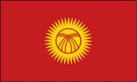**

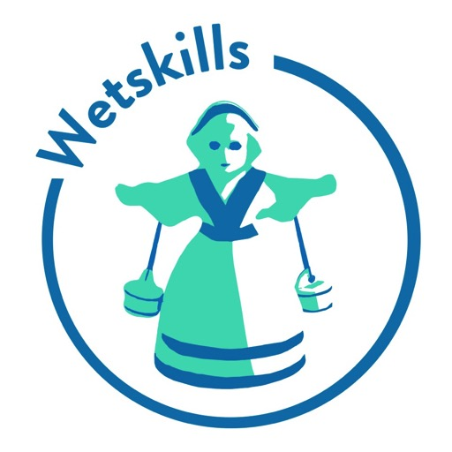

**Wetskills Water Challenges**

**Kyrgyzstan 2018**

***The First Wetskills in Central Asia!***

**Introduction**

The National Water Resources Management Project – Phase 1 (NWRMP-1), a World Bank funded project in Kyrgyzstan asked the Wetskills Foundation to organize a Wetskills Challenge, where International and Kyrgyz students work on real life cases from the program and give an out-of-the-box advice from their perspective. For this request, Wetskills Foundation adapted their unique Wetskills formula, proven in more than 30 events in many countries across the world. Wetskills-Kyrgyzstan 2018 was organized from 15 to 26 October in Bishkek and surroundings.

This report shows the results of Wetskills-Kyrgyzstan 2018. A special thank for our partners: National Water Resources Management Project – Phase 1 (NWRMP-1), World Bank and Kyrgyz National Agrarian University (KNAU) for their cooperation and support. We personally thank: Mr. Beishekeev, Mrs. Damira Alchibekova, Mr. Kalybek Zhumaev and Mr. Johan Heymans (all NWRMP-1) for their support, Mr. David Meerbach (World Bank) for his enthusiasm, Prof. Nurgaziev Rysbek Zaryldykovich, Prof. Chortonbaev Tyrgoot Zhumadievich, Prof. Samykbaev Amanbai Kalkanovich and Dr. Bakyt Askaraliev (KNAU) for hosting this great Wetskills edition, Prof. Loginov (KRSU), Dr. Kulenbekov (AUCA) and Dr. Mambetov (KSUCTA) for providing feedback in the preparation and sending some participants. Furthermore a great thanks to all the involved experts and jury members and a very special thanks to all our Participants!

Wetskills Foundation

(Machtelijn Brummel, Frank Tibben and Johan Oost)

*“The combination between International and Local students is powerful. Since they have different knowledge and insides and can help each other understand the real issues in the study cases.”*

- Machtelijn Brummel, programme manager Wetskills Foundation, supervisor in Kyrgyzstan.

[](http://nwrmp.water.gov.kg/)**Introduction Wetskills Water Challenges**

*Wetskills Water Challenge* is an innovative approach of experimental learning combined with a competitive element. It is a networking and knowledge exchange event for students and young professionals in the water sector. It is a pressure-cooker for creative ideas based on applied research.

The *Wetskills Foundation* initiates, prepares and organises Wetskills Water Challenges since 2010. Since 2010, Wetskills attracted more than 650 participants in over 150 international universities and organisations. In total more than thirty Wetskills events took place in Asia (China, South Korea, Taiwan, Indonesia, The Philippines and India), Central Asia (Kyrgyzstan), North Africa & Middle East (Israel, Oman, Morocco, Iran and Egypt), Sub-Saharan Africa (South Africa & Mozambique), Europe (United Kingdom, Romania & The Netherlands), Latin America (Colombia) and North America (United States & Canada).

***In short, Wetskills brings:***

+ Transdisciplinary and transcultural cooperation in practice;

+ Integration of students and Young Water Professionals;

+ Real-life challenges provided and supported by the sector partners;

+ Informal and energizing ice-breaker during a larger formal event;

+ Positive PR for the organising partners and involved organisations;

+ Link between universities and working field;

+ Follow-up activities and business (under the name WetsNext);

+ Proven concept in more than fifteen different countries worldwide.

**Wetskills Water Challenge Kyrgyzstan 2018**

***Goal***

The water- and irrigation sector in Kyrgyzstan is facing a transition from the old Soviet-built irrigation system to a new and future proof irrigation system.

***Tasks***

Five cases from the overarching NWRMP-1 project where formulated. The central theme was: ‘*How to organize and finance the Water and Irrigation Sector in Kyrgyzstan in a resilient way for a sustainable future?*’

* Case 1: Financing irrigation: subsidies, cost recovery or Public Private Partnerships (PPP)?
* Case 2: Future Organization of the irrigation and drainage sector
* Case 3: Water Resources, Water Use and Climate Change
* Case 4: Organization of the water resources sector
* Case 5: Rehabilitation of schemes or new schemes?

The Cases of this Wetskills event can be found at Annex 2.

***Programme***

The programme of Wetskills-Kyrgyzstan 2018 started on Monday 15 October 2018 with the inauguration and the first fieldtrip with teambuilding activities. After about two weeks the programme ended with the final presentations on 26 October.

The programme of this Wetskills event can be found at Annex 1.

A Day-to-Day report with pictures is written in Annex 3.

***Involved people***

25 Dutch, German and Kyrgyz students, from five different Universities in Bishkek, (Kyrgyz National Agrarian University (KNAU, also local host of this Wetskills event), Kyrgyz-Russian Slavic University (KRSU), Kyrgyz State University of Construction, Transport and Architecture (KSUCTA) and American University of Central Asia (AUCA)), worked on these cases and presented their solution and advice in the Wetskills finals on Friday 26 October 2018.

In Bishkek, two supervisors, Machtelijn Brummel and Frank Tibben (Wetskills Foundation), worked with the students as well as with the local hosts at the University and the Ministry. Johan Oost (Wetskills Foundation) prepared the programme in Kyrgyzstan and The Netherlands and was in charge for the project management.

The Jury of the Wetskills Challenge Kyrgyzstan 2018 consisted of 5 members:

* Ms. Rosa Bekboeva, professor at KNAU University
* Ms. Damira Alchibekova (representative from the PIU and the NWRMP project)
* Ms. Aiperi Djailoobaeva, Young water professionals and Wetskills alumni
* Mr. Johan Heymans (Dutch expert involved in the NWRMP-1 project
* Mr. Bakyt Makhmudov (representative from the Swiss Embassy)

***Results***

Each of the five teams came up with an out-of-the-box idea for their challenge. The team presented this on a Pitch and Poster. The presented Pitches at the finals can be seen on [www.wetskills.com](http://www.wetskills.com) and the Wetskills Youtube Channel. These results of the Wetskills-Kyrgyzstan 2018 can be found in the Annex 4

**PR**

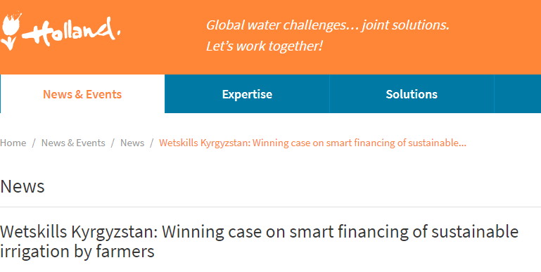Published on 2 November 2018 @ <https://www.dutchwatersector.com/news-events/news/33968-wetskills-kyrgyzstan-winning-case-on-smart-financing-of-sustainable-irrigation-by-farmers.html>

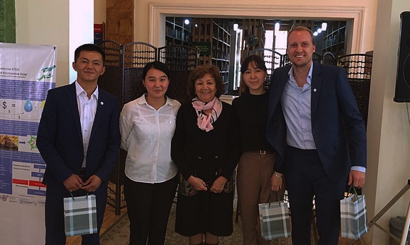  
‘Producing electricity to provide funds for water infrastructure by reinvesting money to be used by local farmers, instead of import and loans’, grabs the core of the concept for financing the irrigation sector in Kyrgyzstan, said the jury when it announced the winning Russian-Dutch team of the Wetskills Water Challenge in Kyrgyzstan.

The final of the challenge took place at the Kyrgyz National Agrarian University in Bishkek on 26 October.

|  |
| --- |
| dws-wetskills-kyrgyzstan-pitch-350px |
| *Students and young water professionals from the Netherlands, Germany, China and Kyrgyzstan pitched their ideas on how to solve real water problems in Kyrgyzstan.* |

**Aging irrigation infrastructure**  
Kyrgyzstan is a water abundant country but its Infrastructure for irrigation, like canals and pumping stations, often date back to the Soviet era in the 1950s.

Because the infrastructure is so old, systems are in dire need of rehabilitation to prevent further deterioration of the irrigation infrastructure.

To be able to finance the modernization, the winning team (*on top photo*) came up with a concept to fund investments in the Kyrgyz water sector, focusing on hydropower development and the use of crowd funding.

The concept suggests the creation of water reservoirs, owned by farmers, for the production of hydropower to generate income. The water in the reservoirs can be used by the farmers for their own irrigation.

**Transparency to potential investors**  
The interesting aspect is that the team considers crowd funding as an important element to create ownership for farmers and generate more transparency.

This can attract more international investors, although the team especially eyed the diaspora of Kyrgyzstan. Living outside the country, these former inhabitants of Kyrgyzstan are keen to invest in and support their home country.

|  |
| --- |
| dws-wetskills-kyrgyzstan-field-trip-350px |
| *One of the field trips to an irrigation area where the participants had meetings and discussions with the farmers.* |

**A two-week pressure cooker**  
The winning concept was developed in a two-week pressure cooker event by the team ‘Watek’, consisting of Jibek Turgunbaeva (Kyrgyz National Agrarian University (KNAU)), Zarina Kaarova (Kyrgyz State University of Construction, Transport and Architecture), Jamalidin Sadridin Uulu (Kyrgyz Turkish Manas University) and Bas Merten (Wageningen University, Netherlands).

The jury had a hard time choosing a winner between the five water-related out-of-the-box solutions of the 25 students and young professionals from the The Netherlands, Germany, China and Kyrgyzstan.

**About Wetskills**  
The Wetskills Water Challenge is a two-week pressure cooker programme for students and young professionals with a passion for water from all over the world.

In transdisciplinary and transcultural teams they work together on water-related challenges. Their assignment: develop innovative and out-of-the-box solutions for water challenges in a fast-changing world. The challenges are real life and cover local cases from companies and (governmental) organisations within the water sector.

This news item was originally published on the websites of **[Wetskills](https://wetskills.com/event/wetskills-kyrgyzstan-2018/" \t "_blank)** and **[Kyrgyz National Agrarian University](http://fupr.ucoz.ru/news/mezhdunarodnyj_obmen_studentami_praktika_mezhdu_nacionalnymi_i_mezhdunarodnymi_vuzami_kak_uluchshit_upravlenie_i_finansirovanie_vodnom_khozjaj/2018-10-20-118" \t "_blank)** (in Russian only).

**Recommendations**

Based on the experiences in Kyrgyzstan the involved supervisors of Wetskills Foundation has some recommendations to improve the water and irrigation education:

* Promote and stimulate integral thinking in education and working environments.
  + Challenge the students to see the benefits for other stakeholders
  + Try to find win-win situations and multi-beneficial solutions
  + Try to see situations on different perspectives
* Promote and stimulate interdisciplinary studies and stimulate teamwork in interdisciplinary teams. Both in education and jobs. Exchange programs between research groups and universities.
  + Try to find time for this during study and work
  + Create project between universities to learn ‘how to exchange and cooperate’
* Create attractive Alumni meetings to stay in touch with Wetskills participants. This is a rather simple idea to organize yearly.
  + Use the Alumni to promote the water and irrigation sector
  + Find out what the young generation wants in their career and use this
* Offer attractive career opportunities and jobs in an attractive water sector. During Wetskills Kyrgyzstan it was especially clear that no one would like to work in Kyrgyzstan after education due to, as they said, unattractive and not challenging jobs.
  + For example incorporating and developing digital and innovative tools motivate young water professionals. The results of team 2 (Future Organization of the irrigation and drainage sector) focuses on this recommendation

Signed by Johan Oost (managing director Wetskills Foundation):

10 December 2018



**Annex 1: programme Wetskills-Kyrgyzstan 2018**

|  |  |  |
| --- | --- | --- |
| Day | Activity | Location |
| Sun. 14 October | Arrival international participants \*No program planned \*pre-meeting with the program team \*meet-up in the hostel | Bishkek |
| Mon. 15 October | **Inauguration of Wetskills**  Main building Kyrgyz National Agrarian University (KNAU)  Moderator: KNAU prof. Samykbaev (KNAU)  09.00-09.10: Welcome addresses  Prof. Nurgaziev R.Z. (Rector KNAU)  09.10-09.25: World Bank project  Mr. Beishekeev (Project Director National Water Resources Management Project phase 1)  09.25-09.40: Introduction Wetskills programme  Machtelijn Brummel (Wetskills Foundation)  09.25-09.45: Keynotes: Kyrgyz Water and Irrigation sector  Prof. Bekboeva R.S. (KNAU)  Prof. Loginov G.I (KRSU)  Dr. Kulenbekov Zh. (AUCA)  Dr. Mambetov E.M (KSUCTA)  10.45: wrap-up  10.50: Walk to Faculty of Irrigation Engineering, Ecology and Land management (WaterMuseum)  **Meeting the group**  WaterMuseum  11.00-11.15: Coffee & Tea Break  11.15-11.45: Presentation and visit to WaterMuseum  Dr. Drugaleva E.E. (Head of Land Improvement and Water Resources Management department, KNAU)  12.00-12.10: Wrap-up | Kyrgyz National Agrarian University (KNAU) |
| **Teambuilding @Ala-Archa National Park**  12.10-14.00: Lunch and Check-in hostel  14.00-18.00: Ala-Archa National Park visit  During the visit: Picture game (team building activity)  Walking / informal chatting / Social activities  Option \*Bishkek City Tour (in case of bad weather conditions) | Ala-Archa National Park |
| 19.00-22.00: Welcome dinner | Bishkek |

|  |  |  |
| --- | --- | --- |
| Day | Time  Activity | Location |
| Tue. 16 October | **Field trip to relevant water sites**  07.00: start in bus  09.00-10.00: Chumysh Dam and Atbashy Canal outlet  (Formation, transboundary allocation)  Presentation, site visit and interviewing staff  10.40: West Big Chu Canal Water Intake Facility | Bishkek and surroundings |
| 12.30: Lunch (on the way)  13.30: Ala-Archa reservoir (Water allocation)  16.30: Sovchozny Canal and WUA Ak-Bulak-Suu  Site visits, interviews with staff and farmers  17.00: bus to Bishkek |
| Free time |

|  |  |  |
| --- | --- | --- |
| Day | Activity | Location |
| Wed. 17 October | **Team Announcements**  09.00-10.00 announcing the teams  10.00 -12.00: Preparation of BrainHurricane in afternoon  First brainstorm session (in teams)  Lunch | Kyrgyz National Agrarian University |
| **BrainHurricane**  13.00 Arrival experts  13.00-13.20 Welcome & Wetskills introduction  13.20-13.40 Introductions of the 5 cases  13.40-14.00 Introduction local experts   * Prof. Bekboeva R.S. (KNAU, hydropower expert) * Damira Alchibekova (NWRMP-1 coordinator component 2, off-farm irrigation expert) * Omurjan Segizbaev (NWRMP-1 coordinator component 3, on-farm / WUA expert) * Nurgazy Mamataliev (NWRMP-1 coordinator component 1, River basin planning and law expert) * Dr.Elena Drugaleva (KNAU, irrigation expert) * Dr. Kasiet Musabaeva (ass prof. KNAU, Head Global Water Center in Kyrgyzstan, gender expert) * Jenaliev Financial expert   14.00-14.15 Break  14.15-16.15 Speed dating (15 min per expert)  16:15-17.30: Deadlines, appointments, program & wrap-up6t5 |
| 18.00: BrainHurricane Dinner (guests are welcome) |

|  |  |  |
| --- | --- | --- |
| Day | Activity | Location |
| Thu. 18 October | **Working Days**  Plenary start (process Action Plan)  Work on study cases | Kyrgyz National Agrarian University |
| Deadline Action Plan 14.00 o’clock  Discussion of Action Plan per group with Frank & Machtelijn  Work on study cases |
| Evening Free time |
| Fri. 19 October | **Working Days**  Introduction pitch and poster  Work on study cases | Kyrgyz National Agrarian University |
| Work on study cases  14.30: presentation Niels Thevs, Coordinator Central Asia Programme, University of Central Asia |
| Free Time |
| Sat. 20 October |  | Bishkek and surroundings |
| Free Time |
|  |
| Sun. 21 October |  | Bishkek and surroundings |
| Free Time |
|  |
| Mon. 22 October | **Working Days**  Work on study cases | Kyrgyz National Agrarian University |
| Work on study cases |
| Evening Free Time |
| Tue. 23 October | **Working Days**  Work on study cases | Kyrgyz National Agrarian University |
| Work on study cases  14.00-16.00 Visit to Department of Water Resources |
| Social activity (food from your country/region) |

|  |  |  |
| --- | --- | --- |
| Day | Activity | Location |
| Wed 24 October | **Polishing products**  10.00: concept poster presentation, feedback session  Work on study cases | Kyrgyz National Agrarian University |
| 14.00: Concept Pitch presentation, feedback session  Work on study cases |
| Free time |
| Thu. 25 October | **Deadline Day**  Work on study cases  12.00: Deadline for posters | Kyrgyz National Agrarian University |
| 15.00 Pitch exercise (only for Pitch presenters)  23.59 Deadline Memo |
| Social activity |
| Fri. 26 October | **Wetskills Finals & Awarding**  9.30 Start  9.45 Welcome by Prof. Nurgaziev R.Z. (Rector KNAU)  9.50 Keynote (TBC)  10.05 Overview 2 weeks of Wetskills  10.20 Introduction of the jury  10.30 Finals with pitches  11.30 Poster market (during the whole morning available)  12.00 Awarding ceremony | Kyrgyz National Agrarian University, Library |
| 12.30 Lunch |
| Fare-well dinner  End of program |
| Sat. 27 October | Travel home international participants and supervisors | Bishkek |

**Annex 2: Cases Wetskills-Kyrgyzstan 2018**

***Central theme: How to organize and finance the Water and Irrigation Sector in Kyrgyzstan in a resilient way for a sustainable future.***

For background information about the World Bank National Water Resources Management Project (NWRMP), see the ‘Background document’ and further information, which will be provided in Dropbox.

**Irrigation and drainage Sector**

**Case 1: Financing irrigation: subsidies, cost recovery or Public-Private-Partnership (PPP)?**

Kyrgyz irrigation water is cheap; it is fixed by the Government at a very low level. Farmers pay a small Irrigation Service Fee (ISF) for the irrigation water they are using. At this moment it is estimated that the ISF counts for about 20% of the current budget to manage, operate and maintain (MOM) the irrigation systems. The remaining part of the budget is provided by the Government. The total MOM budget is far from the required budget to do proper MOM and upgrading of the systems, leading to further deterioration of the condition of the irrigation systems. This process is already going on since about 1980, the last phase of the Soviet era. Most of the irrigation systems are currently in need of rehabilitation.

For the future choices have to be made concerning financing the irrigation sector. What is a reasonable amount of money a farmer can pay for his irrigation water? What are the required budgets for MOM? How much can the Government provide? Should the Government continue subsidizing the irrigation sector? Or should there be a focus on PPP for further MOM of the irrigation systems, like water tourism? Are there other options?

*Remark: on this subject the World Bank has reports available in the NWRMP-phase 1. Participants of this case have to do some studying and analyzing this information.*

**Case 2: Future Organization of the irrigation and drainage sector**

The Kyrgyz irrigation sector is divided in a so called off-farm part (the main canal system) which is managed by the Department of Water Resources and Land Improvement (DWRLI) and the so called on-farm part which is managed by Water Users Associations (WUA’s). The context in which these systems are managed is changing quickly, for instance technical possibilities are increasing, the climate is changing, etc. In the current situation technical improvements are taken up in a very limited way. Climate change is hardly used in plans for the future, the number of staff working in the DWRLI is decreasing and staffs are aging. More than 55% of the current staff is over 50 years old, a large number of pensioners keep on working. In the coming years many professionals in the DWRLI will retire and take with them all the practical knowledge. In addition, there is a limited amount of fresh graduates and young professionals who want to work in the irrigation sector.

What are the future technical and social challenges and possibilities to built up or keep a capable management of the irrigation sector? What are the skills required to meet these challenges and tap these possibilities? How should the DWRLI be staffed in 10-20 years from now and what is needed to realize this staffing (training, funds, recruiting, etc.)? How can the irrigation sector attract fresh graduates and energize young professional to stay in the irrigation sector? Can you suggest improvements for the WUA’s?

*Remark: on human resources of the DWRLI and the status of the WUA’s the World Bank has information. You are the professionals of the future who could indicate what motivates you in working in this sector, use this valuable knowledge. This case is focused on creative thinking and brainstorming.*

**Water Resources Sector**

**Case 3: Water Resources, Water Use and Climate Change**

Kyrgyzstan has abundant water resources. An amount of water is used in Kyrgyzstan, but also downstream countries like Kazakhstan and Uzbekistan depend on water flows from Kyrgyzstan. Due to climate change the hydrology of the rivers is going to change. Water demand is increasing. Many sectors depend on water: agriculture, drinking water, industrial use, ecological use, tourism, etc.

What are the main users of water, and how can these users contribute to good water resource management? What is a good water resources management in Kyrgyzstan from the point of for instance water quality, ecology, minimum requirements of water etc.?

What are the future challenges for development of the water sector, like climate change, water pollution, over-abstraction, decreased availability?

What are the adaptation strategies that Kyrgyzstan could adopt to address these challenges?

**Case 4: Organization of the water resources sector**

Kyrgyzstan has abundant water resources. An amount of water is used in Kyrgyzstan, but also downstream countries like Kazakhstan and Uzbekistan depend on water flows from Kyrgyzstan. Due to climate change the hydrology of the rivers is going to change. Water demand is increasing. Many sectors depend on water: agriculture, drinking water, industrial use, ecological use, tourism, etc. But they hardly contribute financially to the water sector. Water resource management functions are divided over about 10 different agencies. River Basin Management organizations are hardly in existence, in case they exist they have very limited capacity, power and budgets. River basin planning is hardly practiced.

Which options are there to (re)structure the sector so that it is managed more efficiently and sustainable? How would you manage the water sector reform process, with staff and budgets shifts?

What are the skills required to meet the challenges of the water resources sector? How many people with which skills are needed to work in the sector? How should training and recruiting be organized? From which budgets of other financial sources should these activities should be funded?

How should the water resources sector in the future be financed, and how much would it costs? Subsidies, fees, taxes? What is further needed to built up a functioning water resources sector?

**Case 5: Rehabilitation of schemes or new schemes?**

Most of the irrigation schemes in Kyrgyzstan are in need of rehabilitation. Deferred maintenance in the past 30 years has led to this situation. In some schemes the required investment for rehabilitation and modernization is very high. Which level of investment is still justified for rehabilitation, should certain schemes be taken out of production?

An option to be considered for the future is to invest in new schemes. In such new schemes the system can be built up according to the current requirements. The existing systems were constructed in the Soviet plan economy, which is very different from the current requirement. In the Soviet period systems were built for large collective farms, nowadays farming units are much smaller, but current Water Users Associations are in many cases following the borders of former collective farms. How could investing in resilient irrigation schemes in Kyrgyzstan be organized to care for a sustainable future? Should be the focus on investing in rehabilitation of schemes, constructing new irrigation schemes, or find a middle way?

**Annex 3: Day-to-day report Wetskills-Kyrgyzstan 2018**

***15 – 26 October 2018***

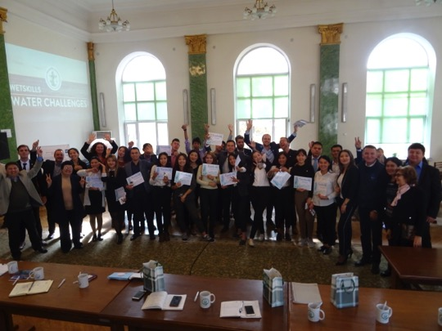

**Day 1 – 15 October. Wetskills Kyrgyzstan is on!**By Kennard Burer and Sultan Alibaev

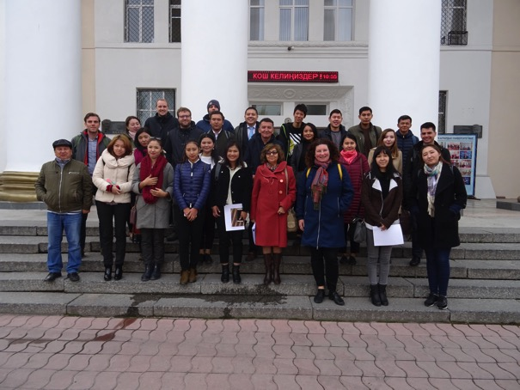

 Welcome to this exciting Wetskills Kyrgyzstan 2018 in the green city Bishkek. It is the first time we meet as 25 students from Europe and Kyrgyzstan and experts from 6 different Kyrgyz universities.

The Kyrgyz National Agrarian University (KNAU) was the host of the Opening ceremony of Wetskills. After an introductory talk from Prof. Chortonbaev T.Zh (Vice-Rector KNAU),  Mr. Beishekeev (World Bank Project Director National Water resources Management Project Phase 1) and Machtelijn Brummel (Wetskills Foundation) and keynotes from the experts (Prof. Bekboeva R.S., KNAU, Prof. Loginov G.I., KRSU, Dr. Kulenbekov Zh., AUCA, Dr. Mambetov E.M., KSUCTA), we made a visit to the KNAU Faculty of Irrigation Engineering, Ecology and Land Management water museum. It was very beautiful and made with a lot of eye for details. The museum is surprisingly interactive as they try to explain the local water issues for school children with toys when they come and visit.

We were honoured by the local university and enjoyed a nice “coffee break”, which was more like a extensive breakfast. Great food with sharing good stories.

After that we went by bus to Ala Archa National Park, which is stunningly beautiful mountain area with peaks of more than 4000 meters. Fresh air felt so good and we made a walk along the river. It was very cold, even for Kyrgyz students, as there was already snow in the mountains. This nature area has more 40 types of animals such as deer. With the snow leopard being the most special.

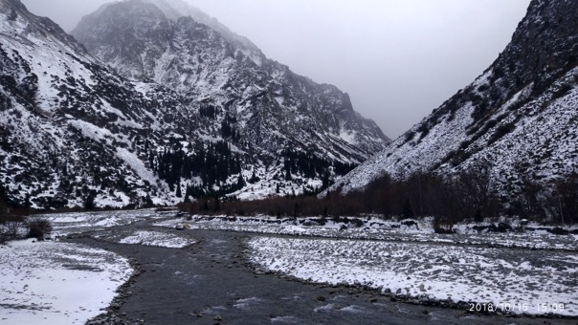

From a personal view, we are excited to see a lot of water related places in Kyrgyzstan and are so much looking forward to start working on the cases provided by our sponsor, World Bank. For some of us, it is the first time to meet and talk so closely with international students. The atmosphere in the group is so good. We already sang Kyrgyz and Dutch songs in the bus and everybody try to learn more and speak English.

We hope to learn much more during this project about water and the issues here in Kyrgyzstan. We have to learn to understand the problems here in Kyrgyzstan and at the same time share our knowledge to help others. And we have to come up with more out of the box ideas to solve these issues. We feel that Wetskills is a good opportunity to make this possible and we are very great full that we can participate.

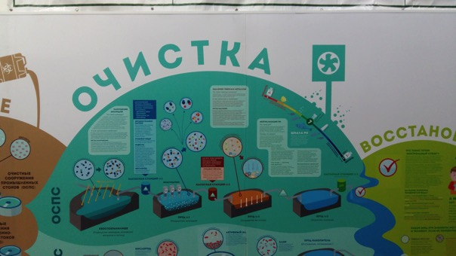

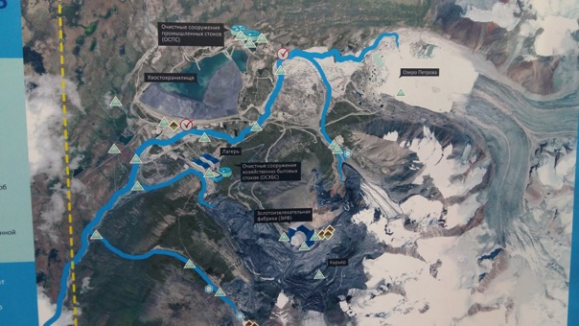

**Day 2 – 16 October. Water canals, reservoirs and making friends**By Adrian Labonde & Beksultan Samagan Uulu

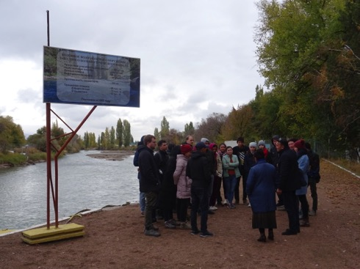

Early this morning, we got picked up by our dear host Mr. Kalybek from the National Water Resources Management Project (NWRMP) from the World Bank at our hostel 312 in Bishkek. Today on the agenda: exploring some of the major water canals, first meeting with a Kyrgyz Water Users Association (WUA) and getting a first grip on how river water is shared between Kyrgyzstan and Kazakhstan. The picture below is showing an overview of women who have the most children, and therefore have a lot of hectares of agriculture land, since every person got a piece of land after the collapse of the Soviet era after 1991.

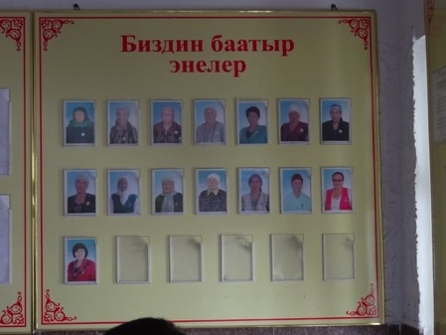

 Our first stop was the West Big Chu Canal Water Intake Facility. From here the Chu river is divides into two branches, providing irrigation water to downstream regions. Some 48 % of the Chu river water is provided to downstream Kazakhstan. At the control room we saw how water is diverted automatically, depending on water levels in the system and downstream demands.

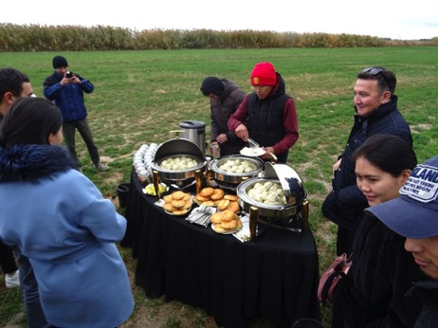

The second stop was at the UZUNKYR Water Users Association, where two representatives have been interviewed on how water in the tertiary canal is managed and divided among the water users.

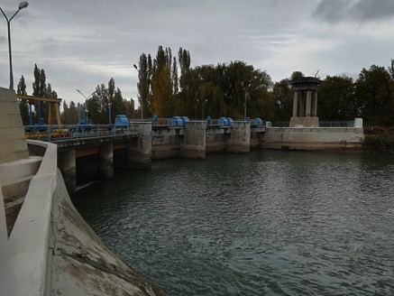

It has been a cold day with snowfall. Winter has arrived, and temperatures could drop to -30 during winter. Thanks to our caterer, a lunch break with (very appreciated) hot tea was held on our way to the next stop, the Ala-Archa water reservoir.

 The bus ride gave time to socialise. For some, it was an intense clash of cultures, certainly lots of laughing and communication. Friends were made. We ended the day in Bishkek’s city centre, where we visited the big Ala-Too Square with the statue of one of the most important heroes in Kyrgystan; Manas. The art gallery gave a impressing overview of the beautiful aspects of Kyrgyz culture, like horseriding and -games, eagle hunting (not for, but TO hunt), yurts and or course, Manas.

|  |  |
| --- | --- |
| https://wetskills.com/wp-content/uploads/2018/10/DSC04246-300x225.jpg | https://wetskills.com/wp-content/uploads/2018/10/DSC04266-300x225.jpg |
| https://wetskills.com/wp-content/uploads/2018/10/DSC04215-300x225.jpg | https://wetskills.com/wp-content/uploads/2018/10/DSC04218-300x225.jpg |
| https://wetskills.com/wp-content/uploads/2018/10/DSC04228-300x225.jpg | https://wetskills.com/wp-content/uploads/2018/10/DSC04235-300x225.jpg |
| https://wetskills.com/wp-content/uploads/2018/10/DSC04239-300x225.jpg | https://wetskills.com/wp-content/uploads/2018/10/DSC04243-300x225.jpg |

**Day 3 – 17 October. BrainHurricane day in Bishkek**By Kairat Sheisheev, Zarina Kaarova & Ludwig Löffler

This morning we got up and got to the university. The first thing we did in the morning was a quick introduction to remember each other’s names better. After playing some games to get to know each other we started playing the ‘fish pond’ game in order to learn something about the problems and issues with common goods. The game was interested, even though the results were extremely different. While one group was very well fed and only had 2 fish in their pond left another group was close to starvation but had over 40 fish in their pond.

After a quick presentation where we learned about the wonderful kingdom of the Netherlands we proceeded with the formation of our groups. To get into the cases as quickly as possible 7 experts were invited to a BrainHurricane so each group could talk to each of them for 15 minutes. This sessions were extremely productive and intense. The experts came from different fields (hydropower, on- and off-farm management, irrigation, finances and different government departments), which made the talk interesting. In these quick talks we already had a lot of controversies.  We asked all sorts of questions that helped our group. All cases are original in their own way. Each group should identify new methods for solving problems in the water sector and propose new ideas that help to reach a new level.

After a quick wrap up session we headed to “Central Plov” for a truly delicious meal shared with all participants and the experts. We had different salads, tomatoes with onions, and of course Plov. It was flavoured with cinnamon and garlic and therefore extremely delicious. Even if Plov is the national dish of Uzbekistan it was still a nice way to connect with Kyrgyz culture.

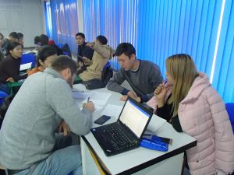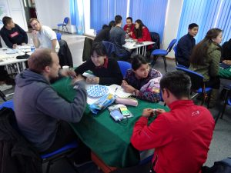

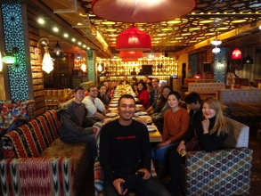 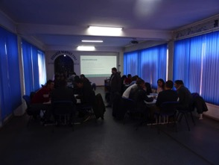

**Day 4 – 18 October. Game, New rules, work on action plan**By Jibek Turgunbaeva & Janara Nurlanova

Today we started again with a little game to learn each other’s names. Unfortunately, a lot of people came late so we had to introduce some new rules that are official from now on. From today on we have new rules about being late. If you’re more than 10 minutes late you have to sing a song and if you come more than 30 minutes late he or she has to pay 1.000.000 som penalty so the supervisors can have a nice massage.

During the game in the morning we threw a small pillow to each other, always shouting out the name while throwing. After two rounds we continued with our cases. We started to make our planning to define what exactly we’re going to do with our cases. This took us until 2 o’clock to finish the action plans. The plan was divided in introduction, background, goals, methods, focus and a schedule for each day. A nice coffee break gave us some time to refresh our minds and be happy because the food was really tasty. We really had a lot of food.

After being fully replenished we finished our planning and started to discuss the action plan with our supervisors. Every group explained their planning and answered critical questions about what they’re going to do.

Even if it was cold outside the atmosphere in the group working room was really positive, busy and productive. The day was a lot of fun and exciting.



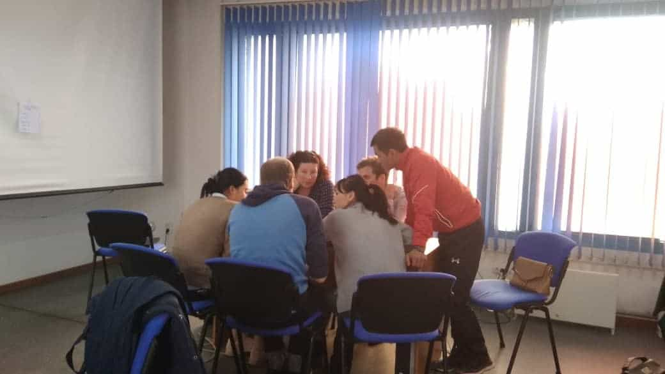

**Day 5 – 19 October. Research in the field**

By Saltanat Kylychbekova & Tilek Askaraliev & Nuraiym Zhuma Kyzy

This morning we got up and went to the university. The firstly in the morning what we did was a quick introduction to remember each other’s names. After the game every team started work with their cases . At 11 o’clock Machtelijn and Frank showed us example how we need to presentation our works. We had a lunch at 12:20 ,it was so tasty. After the lunch we continued making our plans for monday. Then Niels Thevs visited us for sharing with his experiences and ideas . We were glad to meet him and get some important information. The day was really serious and productive for each team.

  
‌

**Day 6 – 22 October. After the weekend**  
‌by Kymbat and Nargiza

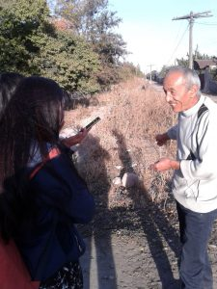Today we will start at 9:00 o’clock in the KNAU. Students and supervisors were rested and full of energy after the weekend. The divided five teams interviewed water experts. At first, our team went to the agrarian college to expert Almaz Imanaliev. Thanks to him, we received the necessary information and course for further action.

By 12:00 o’clock at the university a delicious lunch was waiting for us. We enjoyed eating and chatting with each other. After lunch our team went to the Sokuluk district village Kun-Tuu. We met with the farmers KasymTalipov and Adilet Seidaliev. We received answers to our questions from them. Find out what problems they have and saw an irrigation system of his village. Farmers mostly grow raspberries. We even tasted raspberries and they where very sweet delicious and ecologically clean. Today was very helpful. We received a lot of information that will be needed for our presentation and in general for us as future specialists.

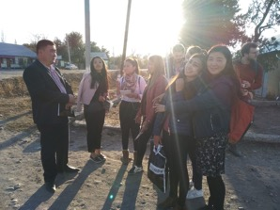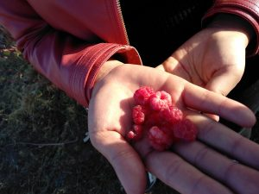

**Day 7 – 23 October. Happy birthday!**By Meerim and Eliza

This day began very positively with Ludwig’s birthday. We sang a Happy Birthday song to Ludwig. Machtelijn and Frank treated all the participants of Wetskills with delicious cookies.

After that each group presented its projects then Machtelijn & Frank gave us their recommendations and advices how to improve our ideas and master our pitches.

Further our presentation of pitches were continued at the Department of Water Resources Building, where experts in water sector judged our ideas and pitches. It was a great opportunity to get valuable advice how to improve our projects.

Overall the day was productive working with pitches as well as interesting with Ludwig’s birthday party continued at hostel with traditional cuisine from the students of Kyrgyzstan, Netherland and Germany.

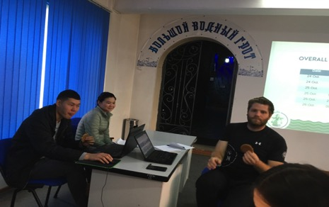

**Day 8 – 24 October. The lesser days remain the more exciting!**

By Beksultan Sharipov and Zhamalidin Sadridin uulu

Today was pretty much productive day, probably the most productive since the beginning of the training. At least for our group (4). We finally made up our poster and our pitch is almost done. We spent all the day in blue room at the Kyrgyz National Agrarian University. We practised our pitch in front of the participants which was quite useful because we are going to have our final day in just two days! We are hoping for the successful outcome and looking for fun. Its always fun to spent time with you guys- you are fantastic! The lesser days remain the more its exciting! Today we were given lots of useful tips from Frank and Machtelijn that will help us to better prepare for upcoming quintessense! 

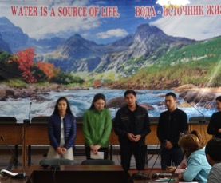 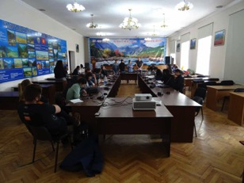

**Day 9 – 25 October. The pressure cooker is fully on!  
By Aziz, Solida and Kunduz**

Dear readers, hope it will be interesting to know how the Wetskills project going in Kyrgyzstan!

Starting from sunny weather, since the early morning all the participants had a good mood, because all the work, which was done before was almost done and submitted. From the beginning of the day some of us were working on posters others worked on their pitch speech, so we really stressed and busy. On the first part most of the focus was to finish the posters quickly and translate it into Russian. As soon as the time was limited until 12 p.m. we really worked hard. Fortunately, all the teams managed to submit their posters on time. After we had lunch, that was delicious as usual. According to schedule, the next step supposed to be a rehearsal for pitch. Therefore, we had two more hours to practice pitch. Finally, each team performed in front of our organizers Frank and Machtelijn. In view of perfect weather, we decided to present it outside on the fresh air. The change of location really refresh our minds. Frank and Machtelijn listened to us very carefully and gave nice remarks and feedbacks afterwards. Thus, today was very productive day, most of the assignments on which we worked many days was done, so we stay positive in anticipation of the next day where we will perform our results. Hope, it was not boring to read, thank you for attention.

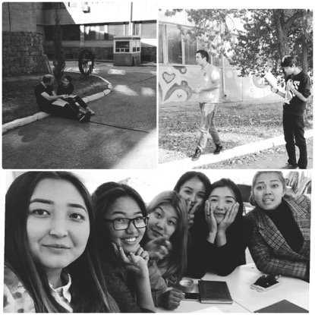

**Day 8 – 24 October. The finals with pitches, poster and papers!**

**Annex 4: Posters and Papers of the teams**

**In this Annex the posters and papers are presented per team.**

1. **English poster**
2. **Russian poster**
3. **Paper (English)**

***Team 1***

**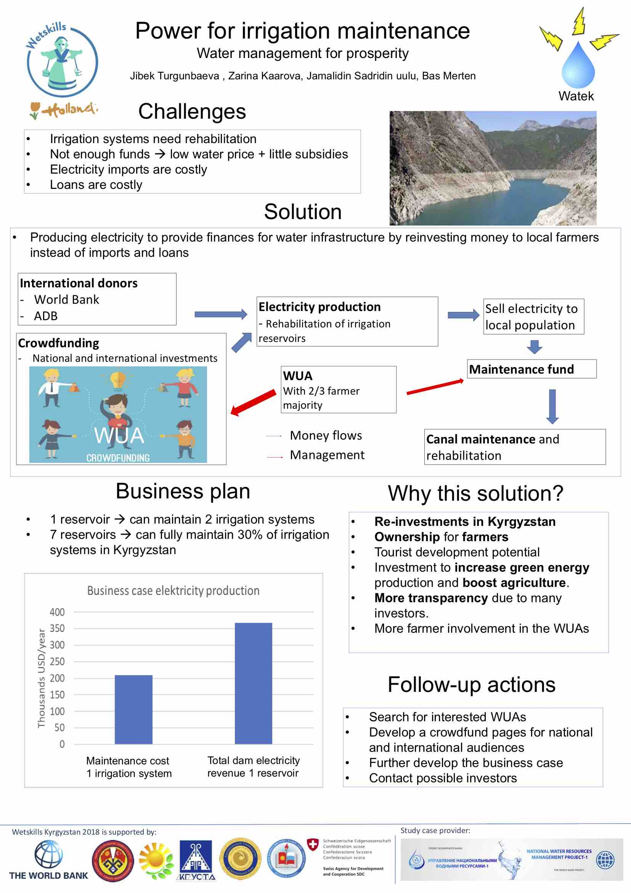**

**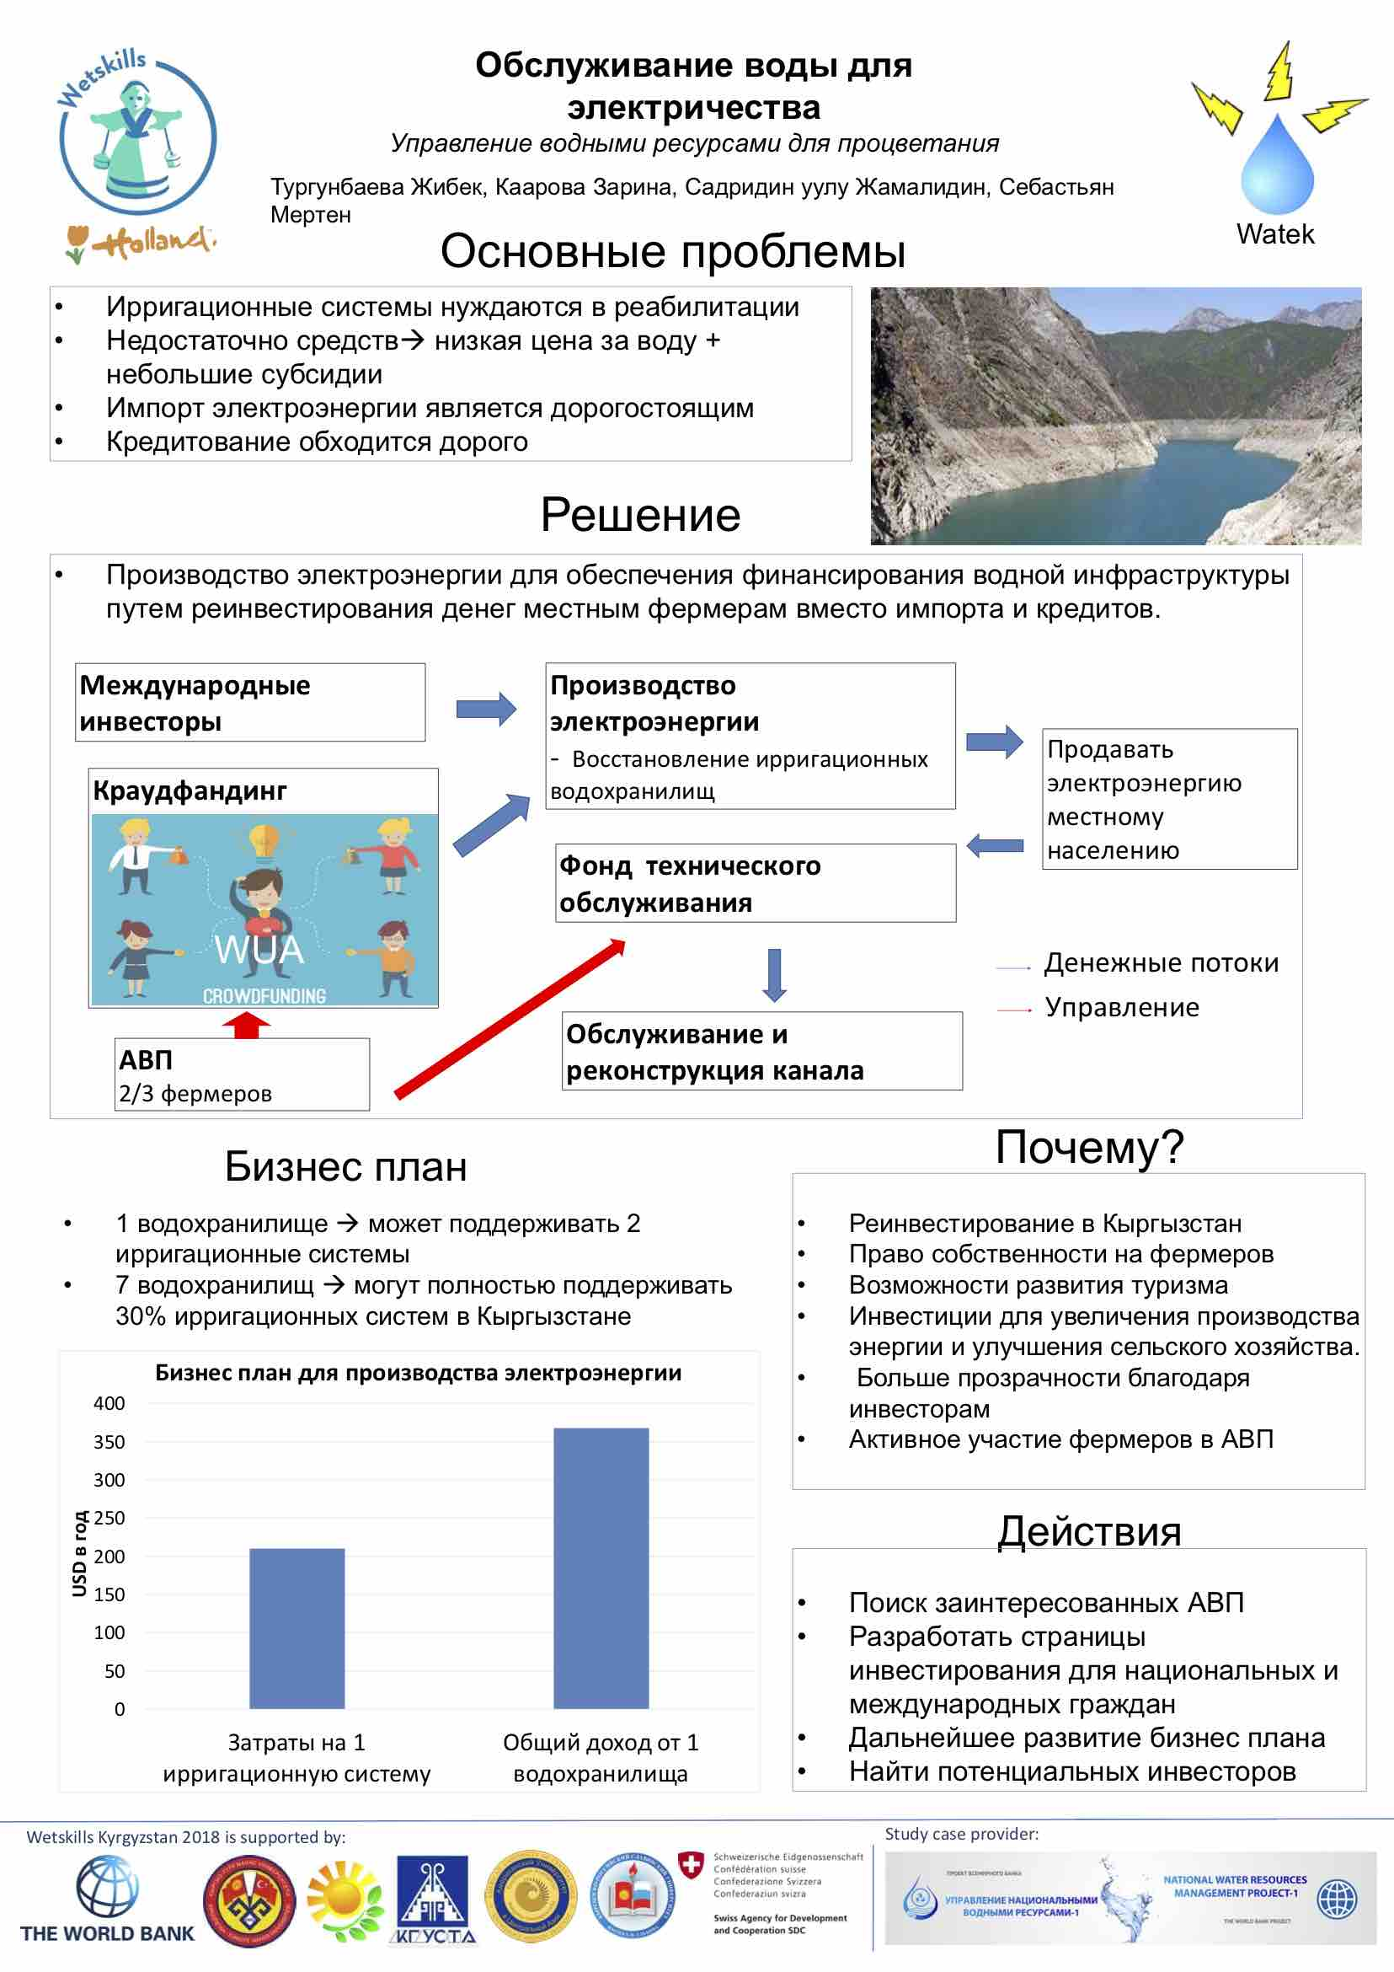**

Financing irrigation system maintenance

Zarina Kaarova, Bas Merten, Jibek Turgunbaeva, Sadridin uulu Jamalidin

**Introduction**

Kyrgyzstan is a water abundant country in central Asia. Most of this water is used in agriculture which is the largest economic sector of the country. Providing food and income for many inhabitants of the country. Despite its wealth in water resources it still has a number of challenges related to agriculture and water use. Infrastructure used for irrigation, like canals and pumping stations, often date back to the 1950s soviet era. Because they are so old, systems are in dire need of rehabilitation to prevent further deterioration of the irrigation infrastructure.

Normally, canal maintenance is paid for by the farmers who pay a fee per volume of water that is used. However, water prices are very low, therefore not enough money is collected from farmers. In addition to the fees paid by farmers, the government also provides subsidies for irrigation system maintenance. But since so many canals need rehabilitation, even these subsidies are not enough. Thus, threatening water access and agricultural production.

Plans to increase water prices for farmers have also resulted in much resistance since this would push more people into poverty and result in higher food prices. The larger maintenance projects that are currently done are mainly financed through international partners like the world bank or European Union. However, in the long-term Kyrgyzstan needs to be able to finance its own irrigation sector.

Today, the main problems in the implementation of projects for the introduction of renewable energy sources are the lack of an appropriate regulatory framework and low electricity prices:

- The cost of electricity produced by large hydropower plants is lower than that produced from renewable energy sources. It is more affordable and has already been brought to every consumer. Recent years show that there is not enough electricity in the country, there are blackouts, there is a problem with the voltage and quality of the electricity supplied, therefore many private organizations, businesses, including households, are looking for opportunities to establish a permanent autonomous independent energy source. At the same time, of course, capital investments are required, which few are willing to invest right away. Therefore, if we compare it with the basic tariff that we currently have, many are not ready to invest in renewable energy sources, because their payback period will be much longer than in European countries.

The second reason is the legislative framework. For the promotion and development of renewable energy sources, regulatory acts are not sufficiently developed. There is a law on renewable energy sources, but in the by-laws there is not enough methodology for calculating tariffs, mechanisms for connecting and selling electricity.

**Objective**

Below the goal of this exercise is described together with some research questions. Since Kyrgyzstan depends on donors for the maintenance, we want to search for new methods to finance the water sector.

* Goal:

To come up with new methods to fund the Kyrgyz water sector.

Focusing on hydropower development and the use of crowdfunding.

**Crowdfunding**

- Currently, Kyrgyzstan heavily depends on outside investors for this maintenance

- To overcome this problem and provide initial capital. Crowdfunding can be used.

- Chat is a waste, keep money in Kyrgyzstan.

- This is an online platform for the Whole world has access to and can thus investing a project.

- At the same time, investments and expeditions are also shown resulting in an transparent overview of the projects finances.

- Especially the million kyrgyz workers abroad should be targeted to invest, since their wages are naively high and they are willing to invest.

- to evzone correct fund use, a rule will be installed that 2/3 of the WUA farmers have to agree with major exendins.

To solute a long term and sustainable source of funding, the crowdfund capital will be used to capitalize on the large hydropower potential of Kyrgyzstan. By upgrading parts of irrigation system to produce electricity, money can be generated and reinvested for maintenance of the irrigation systems. If already existing irrigation reservoirs would be upgraded, one of them would be enough to pay the maintenance 2 irrigation systems. In case of the water reservoirs, tourism activities can be promote. This would increase revenues< provide jobs support climate adaption. One of the most important advantages of hydropower is minimal environmental damage.

**Methods**

We would like to conduct interviews with the following experts:

* Damira Alchibekova, NWRMP-1 coordinator component3, on farm WUA expert.
* Shaimardan Orozaliev, financial expert.
* Possible other experts as well if necessary.

In addition, literature resources will also be used to gain a better understanding of the financial possibilities in Kyrgyz water management.

We also talked to farmers, who gave us a lot of information about how they work together with WUA.

**Investment and Crowdfunding**

Despite the need to overcome a number of problems, the construction of small HPPs and small HPP cascades in Kyrgyzstan as a whole is an interesting and important area of ​​application of investment resources for development banks, private investors and a number of countries interested in obtaining cheap energy, since:

1) In Kyrgyzstan - a network of mountain rivers and rivulets, which conceal a rich amount of energy of the rapid flow of water. Only about 200 rivers and streams, mainly mountain rivers and streams with very fast and strong water flow, the potential of which is literally used by 10-15 percent.

2) The state system of power supply and distribution is very worn out (in more than 70% of cases worn out equipment is used 50 years ago), therefore people in Kyrgyzstan are often disconnected from electricity, especially in villages and regions outside Bishkek, and therefore state-owned enterprises for electricity quality and stability of the provision of electricity are weak competitors to private investors.

3) Other types of alternative energy (except state), especially in villages and regions, have so far been used very little by the population (less than 1%). In some villages almost never used.

4) Electricity needs - are there and are increasing annually. At present, the population of Kyrgyzstan is about 5,000,000 people; in Bishkek, according to unofficial data, it is about 1,000,000 people. The population of Kyrgyzstan is growing annually, according to the National Statistical Committee. In addition, growing demand and unmet demand for hydropower and electricity also emanates from neighboring countries of Kyrgyzstan.

5) Cheap labor - wages and prices are quite low in Kyrgyzstan, especially in regions outside the capital, which will ensure low construction costs for small hydropower plants, i.e. low cost of electricity.

We calculated how much electricity will go out per season and how long it will pay for itself.



**Advantages of hydroelectric power plants**

The work of the HPP is not accompanied by the release of carbon monoxide and carbon dioxide, nitrogen and sulfur oxides, dust pollutants and other hazardous waste, does not pollute the soil. Some of the heat generated by the friction of moving parts of the turbine is transferred to flowing water, but this amount is rarely large.

Water is a renewable source of energy. At least until the streams and rivers dry up. The hydrological cycle (the water cycle in nature) replenishes the sources of potential energy due to rain, snowfall and drainage.

The performance of hydroelectric power stations is easy to control by changing the water flow rate (the volume of water supplied to the turbines).

The reservoirs constructed for hydroelectric stations can be used as recreation areas, sometimes a truly spectacular landscape is formed around them.

The water in artificial reservoirs, as a rule, is clear, since impurities are deposited at the bottom. This water can be used for drinking, washing, bathing and irrigation.

***We will take this opportunity to invest in our electricity and agriculture so that Kyrgyzstan can prosper***

***Team 2***

***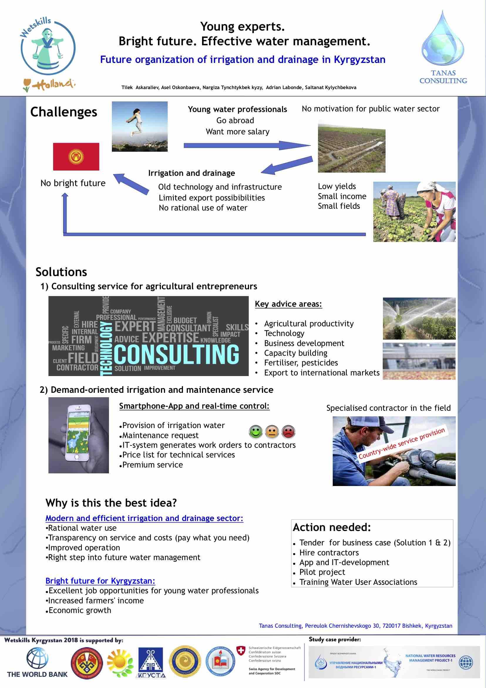***

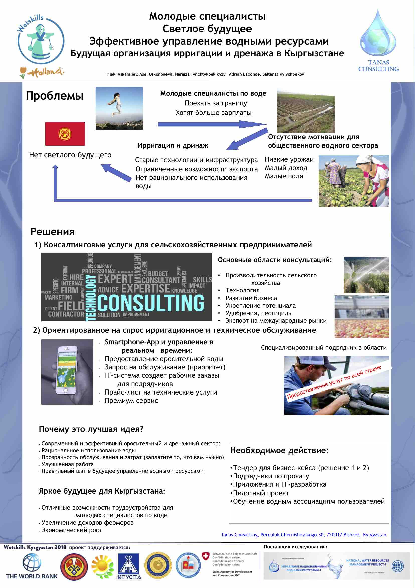

**Future organisation of the irrigation and drainage sector in Kyrgyzstan**

**Young Experts.   
Bright futures.   
 Effective Water Management.**



**TANAS Consulting**

**Tanas Consulting, Pereulok Chernishevskogo 30, 720017 Bishkek, Kyrgyzstan**

**Team:** Tilek Askaraliev, Asel Oskonbaeva, Nargiza Tynchtykbek kyzy, Adrian Labonde, Saltanat Kylychbekova  
**Case owner:** National Water Resource Management Project - I (The World Bank Project)

**Date:** October 25, 2018

**Introduction of the case:**

Kyrgyzstan is a mountain-rich country; only a small part of the land surface is used for agriculture.   
Around 1 million ha of land surface in Kyrgyzstan is irrigated. The irrigated area has sustantially declined after the fall of the Soviet Union. Nonetheless, irrigation and drainage is a criticial factor for agricultural production, due to limited rainfall (200 mm/year).

The irrigation and drainage sector is subject to aging staff, outdated technologies. Moreover, young water professionals have hardly any motivation to work in this sector. Main reasons herefore are: Low salary (around 80-100 dollars/month as experts), intransparency and hence young water professionals seeking for job opportunities abroad. For the future development of the sector, this is a major concern, expecially when it comes to introducing new technologies requring the skill and mindset of young water professionals.

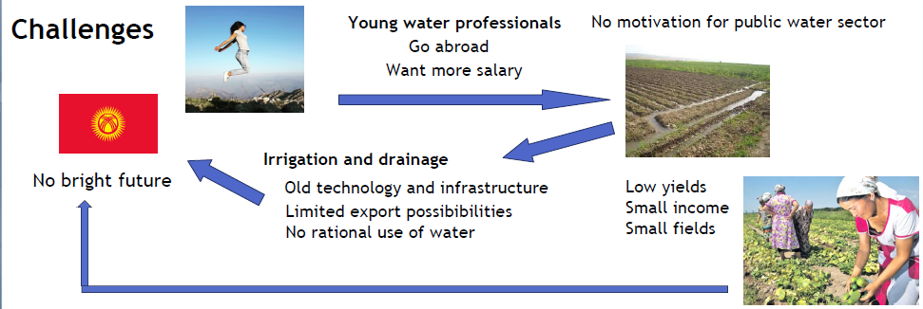Whereas some areas in Kyrgyzstan have modern irrigation and drainage systems (such as lined canals), other irrigated areas face water shortages, poor drainage and sedimented canals. Parts of this can be attributed to insufficient maintenance and lack of funding. In fact, some 20% of a arguably low irrigation fee (around 0.03-0.04 som/m³) is paid to Water Users Associations. Around 80% of this share are required for salaries. As a result, technical service and maintenance is often inappropriate. Corruption is a major concern from government to farm level.   
Moreover, farmers generally have small land area to cultivate. Agricultural inputs, such as fertilisers and pesticides are insufficient to result in high yields. Hence, farmers' income is small and consequently investments are very little. There is little export to international markets. This can partly be attributed to small agricultural production (small fields, low yields) and lack of appropriate certificates as well as processing facilities. Investments into the agricultural and irrigation/drainage sector are low. Hence, prosperity and economic growth is substantially constrained. Young (water) experts will play a key role in addressing these challenges. However, if most of them go abroad, Kyrgyzstan's agricultural and water sector does not have a bright future.

**Scope of the study:**In this study, we concentrate on young water experts, and address opportunities to make the irrigation and drainage sector more attractive for young graduated. Moreover, we look at possible synergies between agriculture and the water sector and explore business opportunies to provide promising jobs for entrepeneurs to stimulate enconomic growth and investment in this country.

**Method and data:**This study used expert consultation in the irrigation and drainage sector, interviews with farmers and background literature. One important knowledge source were in-depth discussion with our team in order to understand the drivers for young water professionals and entrepreneurs to work or not work in Kyrgyzstan. We are aware that, due to limited time for this study (5 days), there are substantial knowledge gaps which should be addressed asap for proof of concepts and follow-up research. Still, we argue that findings regarding the motivation of young water professionals to work in the water sector provide a clear idea that there are hardly any promising job perspectives for those that seek jobs in the Kyrgyz water sector.

**Solution:**As results of this study, we present two concepts that aim to a) modernise the irrigation and drainage sector, b) enhance agricultural production and economic growth, c) and most importanly generate promising jobs for young water professionals and enrepreneurs to engage in Kyrgyzstan.

Firstly, we suggest to set-up a **Consulting Service** to advice farmers and young (agricultural) entrepreneurs in order to make living and substantially increase income. Key advice areas are shown in the following Figure. Those areas aim to make agriculture more productive and stimulate to improve access to internal markets (export). One example here, is that farmers need certificates and critical facilities to do so. For instance, exporting dried fruits requires processing facilities and laboratories, quality management, alongside investments and training. The consulting service is need to combine all required expertises to those that want to exploit business opportunities – e.g. Greenhouse production and cash-crop production.

Seconly, we suggest involvement of the private sector for irrigation and drainage. By introducing a state-of-the-art **demand-oriented irrigation and maintenance service**, it is aimed to improve water provision and maintenance, improve cost-efficiency and make sure that irrigation and drainage is working optimally.

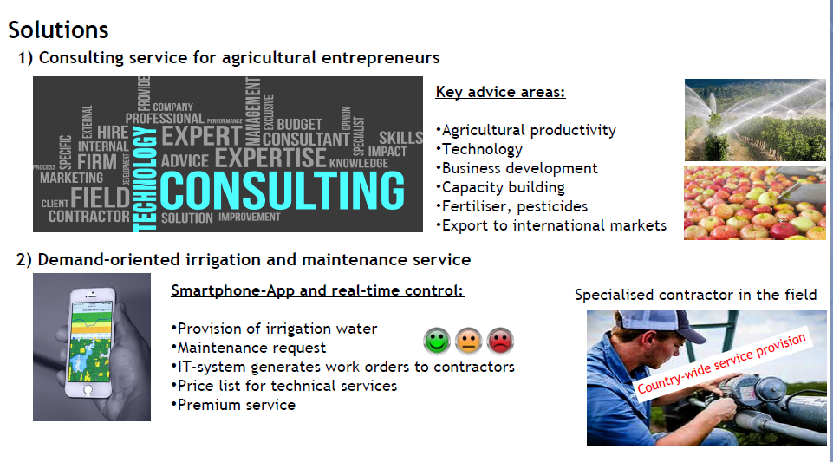By means of smartphone-apps, IT operations and real-time control, farmers will request water provision as well as maintenance on-demand. Using a feedback system for maintenance needs, as shown in the Figure above, specialised maintenance contractors will be sent to the field and workorder will be prioritised. Therefore, water users receive optimal service and operation. The underlying technology of this is found in the field of Integrated Asset Management. With modern software and current advances in technology (smart metering and automation) this approach is viable nowadays. A specialised consulting firm and software development agency will need to further investigate this concept. We suggest to make use of national and international tenders to realise a first pilot project and address up-scaling in Kyrgyzstan.

This solution will need national and international expertise and investment. It presents a business case to be explored. If succesfull, it will provide many promising job opportunities for young water professionals. Important questions to further address are capacity building, involvement of Water Users Associations and the National Governmental Agencies and funding.  
Main risk associated with this approach are intransparency, lack of funding and insufficient capabilities of the aged water sector (staff).

Both solutions will result in the following benefits and required actions as outlined in the following Figure.

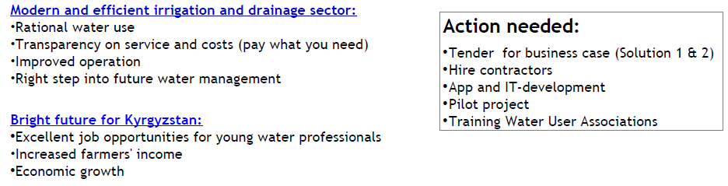**Concluding remarks**

The proposed solutions address modernisation of the irrigation and drainage sector, aim to enhance agricultural production and economic growth and could ngenerate promising jobs for young water professionals and enrepreneurs to engage in Kyrgyzstan.

We strongly suggest to further explore our solutions and concentrate on private sector involvement. One appropriate tool we recommend to make use of is competition (national and international players), research (proof of concept, business cases). We strongly suggest to involve economic expertise and software development and follow-up with a first pilot project. For these solutions external competences are requires. National and international tenders and student competitions should be used to find a capable project facilitator and bring together required expertises and actions.

***Team 3***

**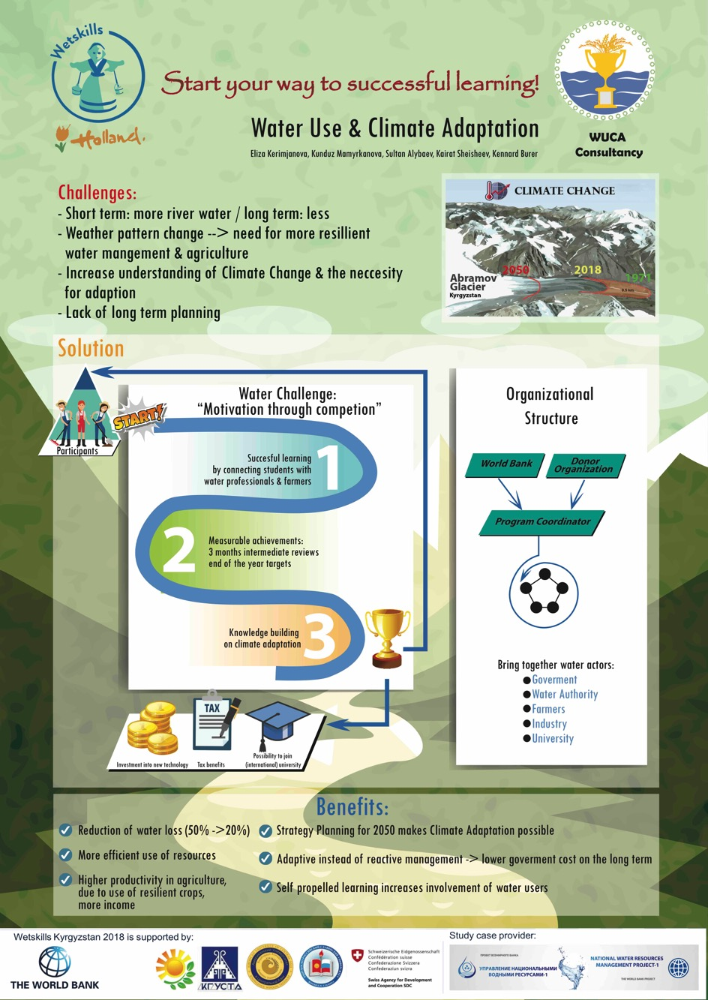**

**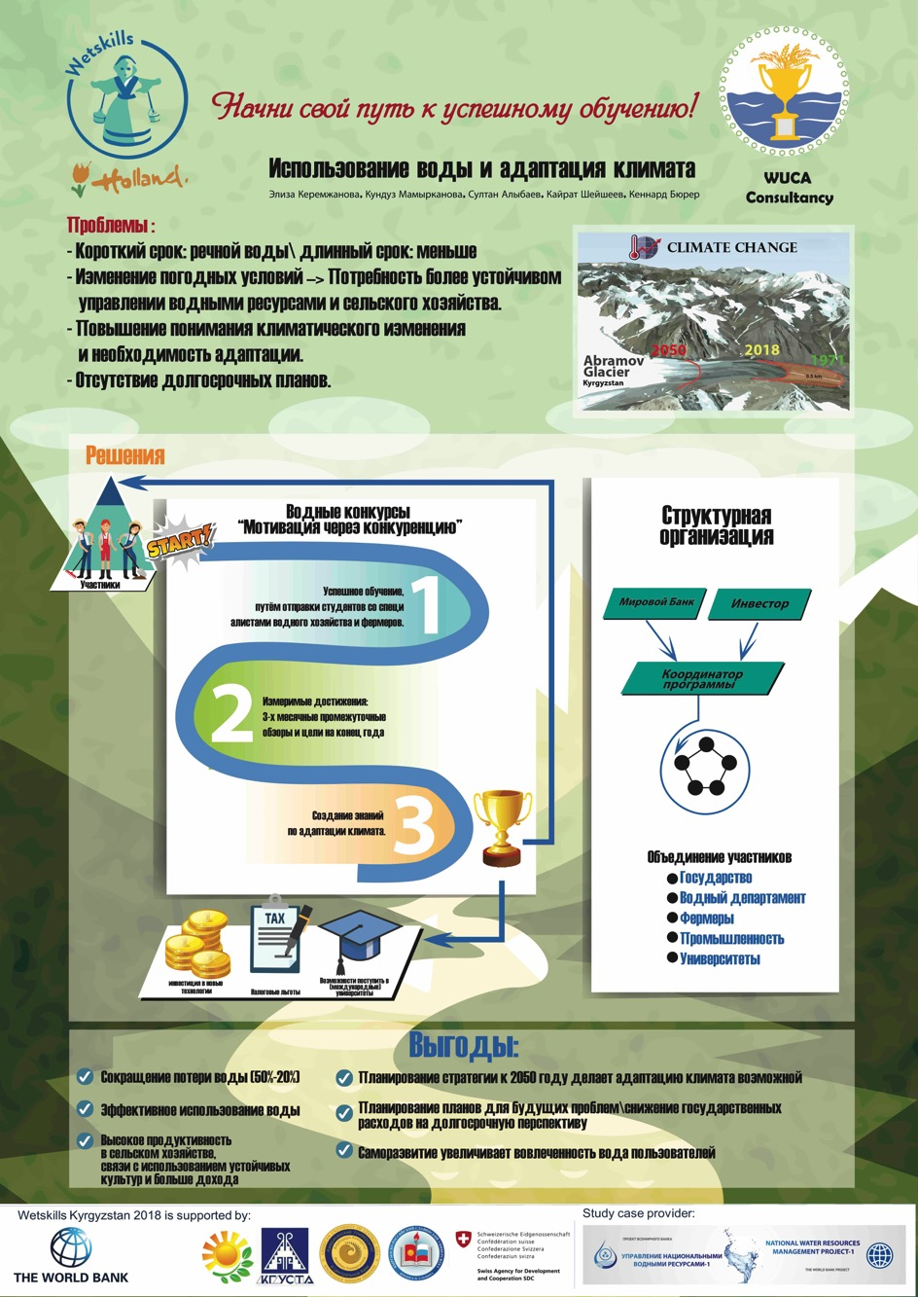**

Water resources, water management and climate change

Composition:

1.Kerimzhanova Eliza

2.Mamyrkhanova Kunduz

3.Shashaev Kairat

4.Alybayev Sultan

5.Ken Borer

Introduction:

The Kyrgyz Republic has significant water resources. The total available water resources in Kyrgyzstan are estimated at 2,458 cubic kilometres, including 650 cubic kilometres (26.4 per cent) of water stored in glaciers, 1,745 cubic kilometres (71 per cent) of lakes, 13 cubic kilometres of potential groundwater resources (0.5 per cent) and 44.5 to 51.9 cubic kilometres of average annual river flow (2 per cent) (figure 1). The total annual volume of renewable water resources is estimated at 46.5 cubic km. 1

The global problem of climate change is one of the threats to the environmental security of the Kyrgyz Republic. Despite the existing socio-economic problems, Kyrgyzstan is aware of the special importance of environmental protection and the rational use of natural resources and is taking all necessary measures to implement the provisions of the UN framework Convention on climate change and the Kyoto Protocol.

Water sector of the Kyrgyz Republic provides 1018, 7 thousand hectares of irrigated land (these lands provide almost 90 percent of agricultural production). The total length of all inter-farm canals is 6502,34 km, of which 2795,91 miles with trim and hydraulic structures 8318 units, gauging stations 3356 PCs, reservoirs – 34 pools, decade and daily regulation – 303, pumping stations – 68 PCs, bridges and level crossings – 2158 PCs. the collector-drainage network (CDN) is 642,46 km.

Problems:

Despite the abundance of water resources, Kyrgyzstan faces a shortage of water for both irrigation and drinking needs. This trend may increase in low-water periods, and each year the deficit will be felt more and more.

A significant part of the water taken in the Republic is lost during use. The reason for the losses is the poor technical condition of irrigation and water distribution systems, equipment wear, application of imperfect irrigation methods.

Agricultural production based on irrigated agriculture is the leading sector of the Kyrgyz economy and consumes the lion's share of water (93%) (figure 2). Among the countries where agricultural land is artificially irrigated, Kyrgyzstan is one of the leaders (78%) (figure 3.). However, there is inefficient use of water.

Figure 2. Water intake structure

[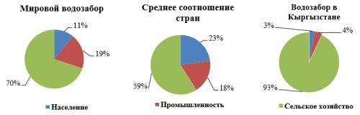](http://static.akipress.org/127/.storage/analytics/images/otrasli/6503b3cb44716392b334b90f1e041a7f.gif)

Figure 3. Share of irrigated agricultural land

[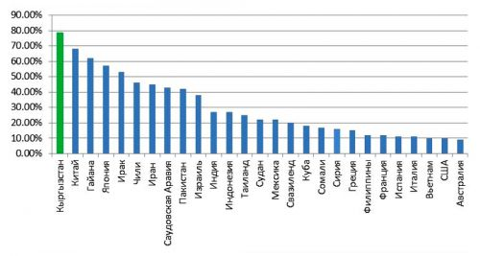](http://static.akipress.org/127/.storage/analytics/images/otrasli/723c35c4e65b85996116d06a23f83592.gif)

Currently, the government of Kyrgyzstan subsidizes from the state budget 90% of the costs for the provision of irrigation services (613 million soms). It is proposed to introduce a two-rate tariff for the supply of irrigation water from the state irrigation network.

According to the forecast of NISI KR, water needs for irrigation and agricultural water supply by 2024 will increase by 57% in one scenario, in another-by 77%.

The existing infrastructure for sanitation and drinking water supply in Kyrgyzstan is also in critical condition, and most of the country's centralized water supply systems are not functioning effectively.

The Kyrgyz Republic faces a number of challenges and problems in the field of water resources management, which are not adequately addressed by existing agencies and organizations with the help of existing economic instruments, or cannot be solved at the expense of the industry's revenues.

There are problems in interstate water allocation, there is no coordinated policy with neighboring countries, the strategy and tactics of the CAR countries are irrational. There is an unfair water allocation for Kyrgyzstan and infringement of interests of Kyrgyzstan on the right of development of water and energy industry.

In this regard, and another factor is that the low level of tariffs (3 thousand per cubic meter) does not stimulate agricultural water saving, and, accordingly, the introduction of new irrigation technologies, it is necessary to reform the economic mechanism of water relations. It should be aimed at the consistent development of the principle of water payment on the basis of flexible regulation of tariff policy. Gradual achievement of self-repayment of costs for operation and maintenance of water management systems taking into account dynamics of real solvency of water users should be provided. In the next 3 years to bring tariffs for services for the supply of irrigation water from the main canals to 8-10 thousand per 1 cubic meter, further increase should not exceed 20% of the previous period. In the long term, strategically important water facilities will be maintained at the expense of the state budget, and tariffs for water supply services from privatized systems should be differentiated due to differences in the cost of these services.

On the above mentioned issues we decided to come up with a 3-year interactive water competition which unites water users but also teaches on the importance of climate adaptations and planning strategies. We have developed a complete and innovative concept based on 3 principles

1. Sociability

2. Ability to achieve your goals

3. Improve knowledge

Communication skills unite water users, i.e. students, farmers and professionals who will be able to work with each other.

The second skill to achieve their goals is carried out by mid-term reviews, every three months and year-end objectives.

Third, improving knowledge on adaptation and long-term planning

After the competition, participants receive rewards in the form of money, tickets to study abroad and a discount on tax.

Advantages of using this water competition

- strategic plan prevents government spending

- water loss will decrease from 50% to 20%

- and economic growth due to increased productivity and adaptability of water management.

- High productivity in agriculture, due to the use of resistant crops and more income.

- Planning strategy to 2050, making climate adaptation possible

- Planning plans for future problems\reduction of public spending in the long term

- Self-development increases the involvement of water users

As a result, thanks to the competition, we save millions of soms, become self-sufficient and most importantly, we have access to successful training.

***Team 4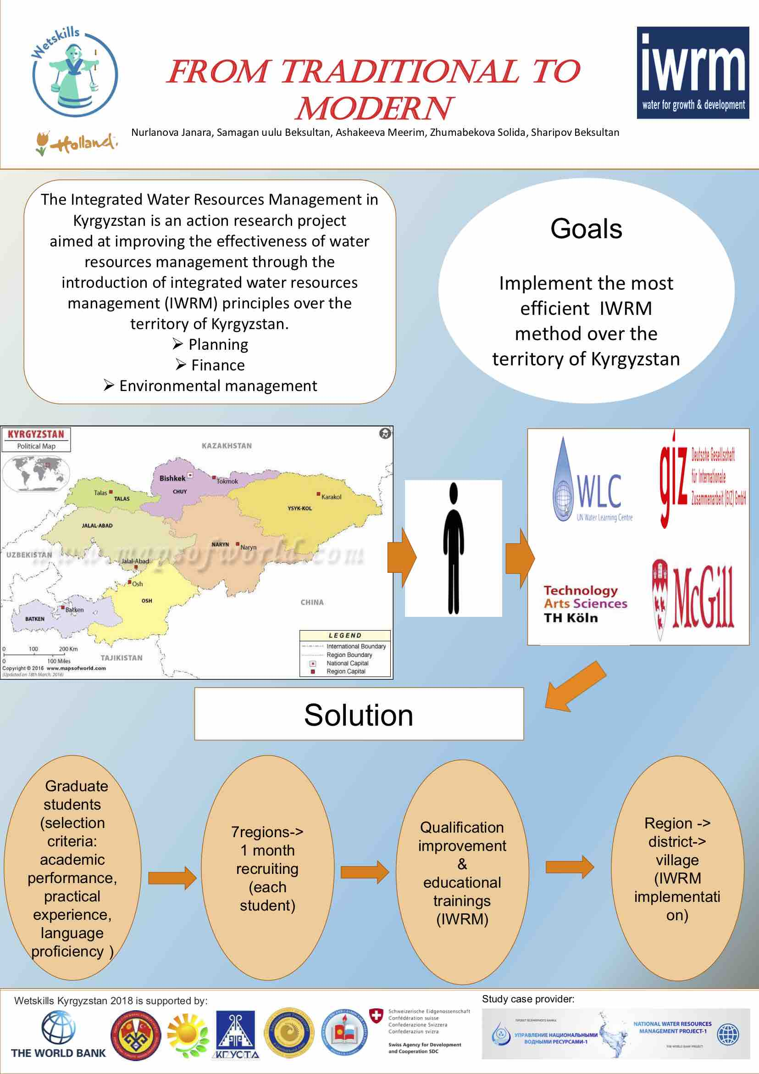***

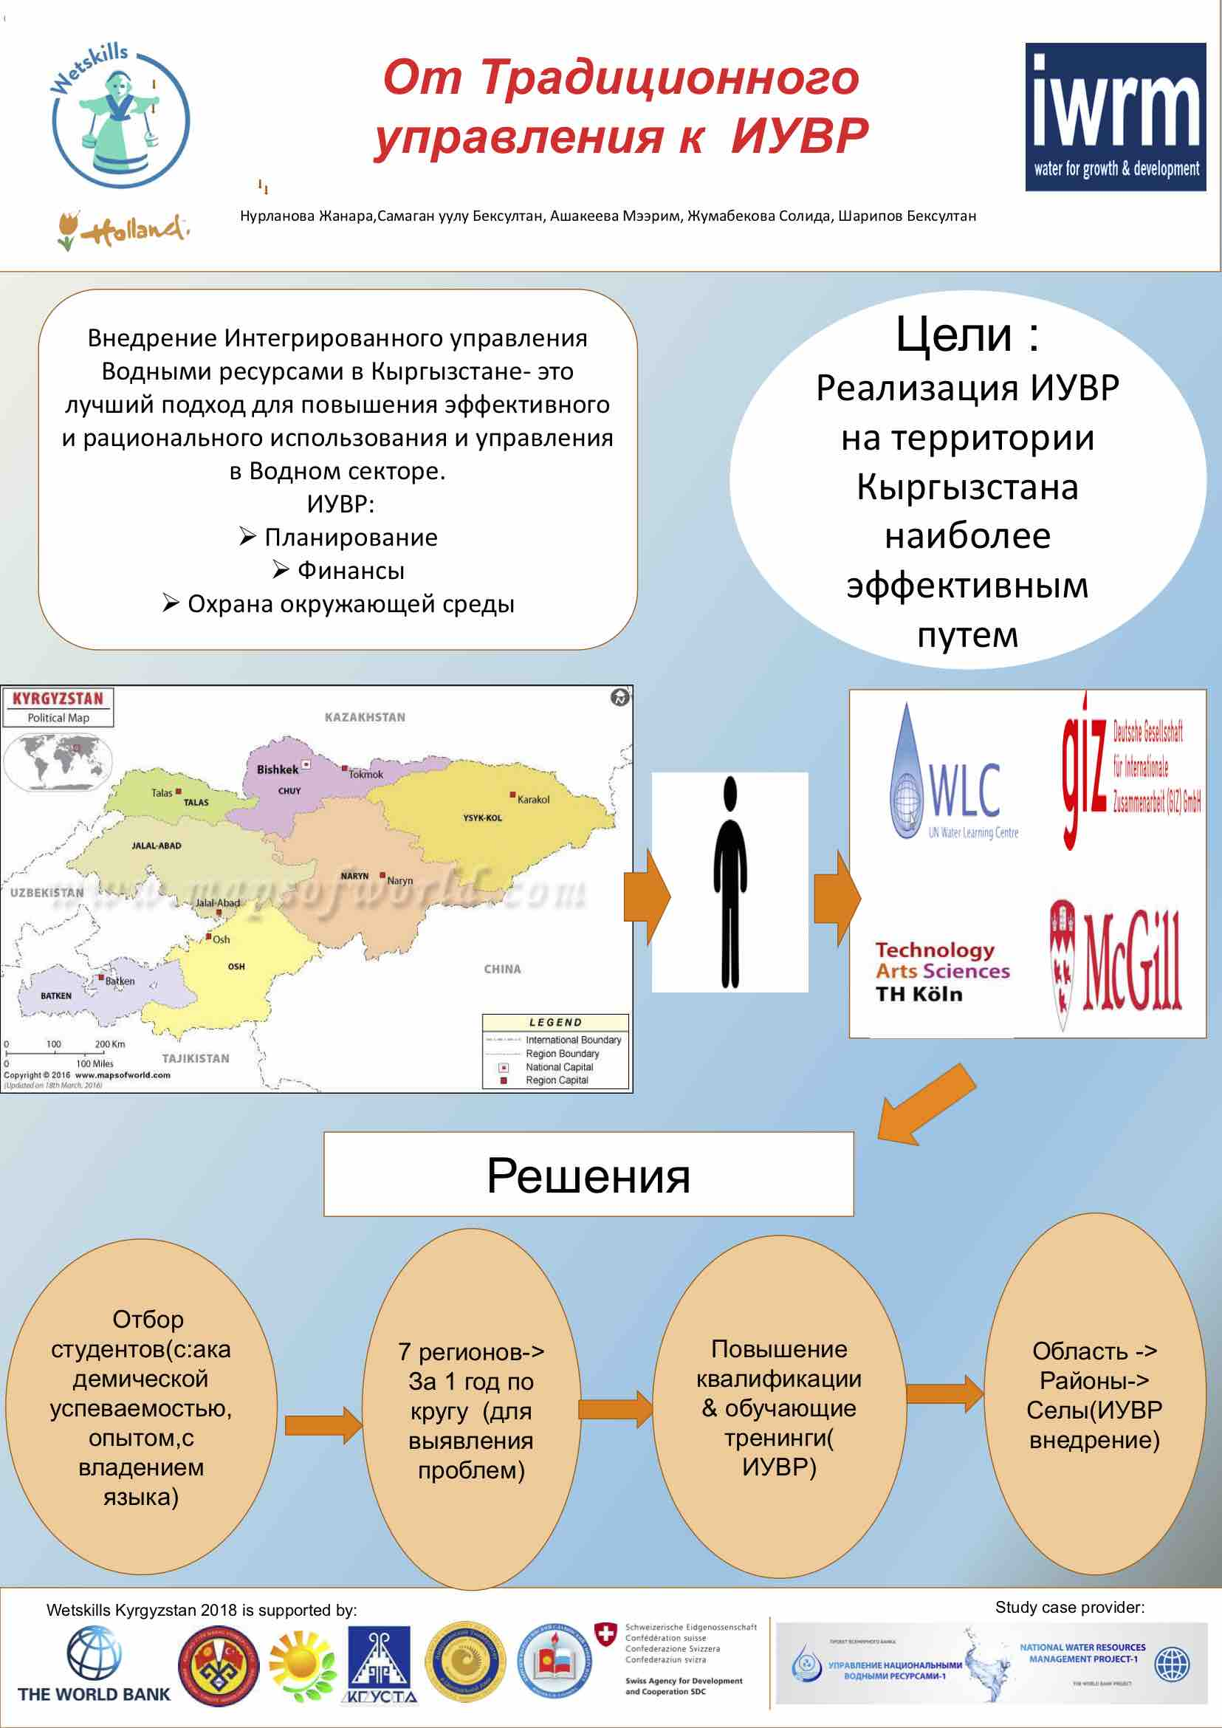

***Implementation of Integrated Water Resources Management in Kyrgyzstan***

**Names investigators, case-owner**

1. Ashakeeva Meerim
2. Zhumabekova Solida
3. Nurlanova Janara
4. Samaganov Beksultan
5. Sharipov Beksultan

**Introduction of the case / Background:**

Kyrgyzstan - the only country in Central Asia, where water resources are fully formed in its own territory, this is its hydrological characteristics, big hydropotential and advantages. Kyrgyzstan has significant resources of underground and surface waters, stocks of which are in the rivers, glaciers and snow bulks. The country has more than 3,500 rivers and streams, which belong to the main pool of the transboundary rivers like- the Syr Darya, the Amu Darya, Chu, Talas, Ili, Tarim and Lake Issyk-Kul. Water resources of these rivers flow through the territory of the Kyrgyz Republic and go to the other countries of Central Asia. Republic does not have water resources inflowing from the outside.

Today the relevance of the theme of water resources is gaining tremendous momentum, not only in Central Asia but also worldwide. Rapid population growth, difficulties in ensuring safe drinking water, water supply does not work or does not meet the established standards. Unfortunately the excess of water also brings damages in such circumstances as mudflows, floods, which drives to material, moral damages and life loss. As State Agency on Hydrometeorology of Kyrgyz Republic states the average temperature of rise over the territory of Kyrgyzstan was equal to 0,18 °C for every 10 years from 1976-2015, it issues warning about melting glaciers, which drives to flooding. According above mentioned problems we decided to come up with the most effective principle of IWRM for Kyrgyzstan.

**Problem Statement:**

The Integrated Water Resources Management in Kyrgyzstan is an action research project aimed at improving the effectiveness of water resources management through the introduction of integrated water resources management (IWRM) principles in over the territory of Kyrgyzstan. The project addresses possibilities for transparent, fair and efficient water allocation mechanisms among water users and between the project regions due to the local needs for water saving, improvement of soil fertility and pertinent environmental issues through the reorganization of water administration.

**Objective of the study:**

Implement the most efficient integrated water resources management system (IWRM) over the territory of Kyrgyzstan

**Scope of the study / terminology:**

Current project covers the whole territory and the water sector of Kyrgyz Republic.

**Method and data:**

Literature review- interview- analysis-choose the best method-implementation

**Results / solution:**

IWRM aims to create sustainable water security within the present constraints and to improve the conditions in the catchment basin. Through the academic and practical education as well as exchange experience of young professionals from Kyrgyzstan to abroad we will fill the gap of poor water and not only management in our country. Some important conditions for implementing IWRM are presented below.

*Political will and commitment:*Political will at all levels can help unite all stakeholders and move the process forward. It is especially needed if the resulting plan or arrangement would create or require changes in legal and institutional structures, or if controversies and conflicts among stakeholders exist. Access to actors outside the water box is essential to move political will, gain sectoral support and ease public pressure for IWRM implementation.

*Basin management plan and clear vision:* Water resources development coordinated among various sectors and users is facilitated by the preparation of a master plan that reflects the individual sector plans and offers the most effective and efficient utilization of the resource.

*Participation and coordination mechanisms, fostering information-sharing and exchange:*The identification of key stakeholders can be facilitated through interviews and meetings. Stakeholder involvement can be defined appropriately for local conditions and improved gradually. Initial sharing of general basin-wide data and information, and further sharing of more specific information, will assist the self-sustaining system.

*Capacity development:* Capacity development and training priorities should be expressed at all levels, including that of decentralized local government. Participants who may be adversely impacted and/or socially marginalized may be stimulated to participate within a consensus-building strategy.

*Well-defined flexible and enforceable legal frameworks and regulation:*It is necessary to assemble and review the full range of existing laws and regulations that  
apply to water-related activities and determine how existing legislation adapts or can be better adapted to accommodate sustainability and integration with regard towater resources management.

*Water allocation plans:* As water is a shared resource, water rights should be flexible in terms of allocation in order to accommodate changes. Preparing a master plan that reflects individual sector plans facilitates the coordination among various sectors and advocates the most appropriate utilization of a basin’s resource.

*Adequate investment, financial stability and sustainable cost recovery:* Coordination for IWRM implementation needs financial sustainability – such as the promotion of cost recovery – and must consider long-term management. Various combinations and roles of international financing and donors such as government grants, public resources, user charges and taxes, donor funds, basin environmental trust funds can be considered as funding options.

*Good knowledge of the natural resources present in the basin:*Adequate knowledge and information on the water resources inventory and human resources of the basin is desirable. Including scientists as water resource managers can help maintain and accrue sound knowledge of the natural resources.

*Comprehensive monitoring and evaluation:* Monitoring and evaluation are essential for ensuring that the current management of water resources is properly implemented, and to identify the needs for adjusting management strategies. Upgrading new technologies is vital for effective performance both of local and central water management.

**Concluding remarks / recommendations:**

 IWRM approaches involve applying knowledge from various disciplines as well as the insights from diverse stakeholders to devise and implement efficient, equitable and sustainable solutions to water and development problems. As such, IWRM is a comprehensive, participatory planning and implementation tool for managing and developing water resources in a way that balances social and economic needs, and that ensures the protection of ecosystems for future generations. Water’s many different uses—for agriculture, for healthy ecosystems, for people and livelihoods—demands coordinated action. An IWRM approach is an open, flexible process, bringing together decision-makers across the various sectors that impact water resources, and bringing all stakeholders to the table to set policy and make sound, balanced decisions in response to specific water challenges faced.

***Team 5***

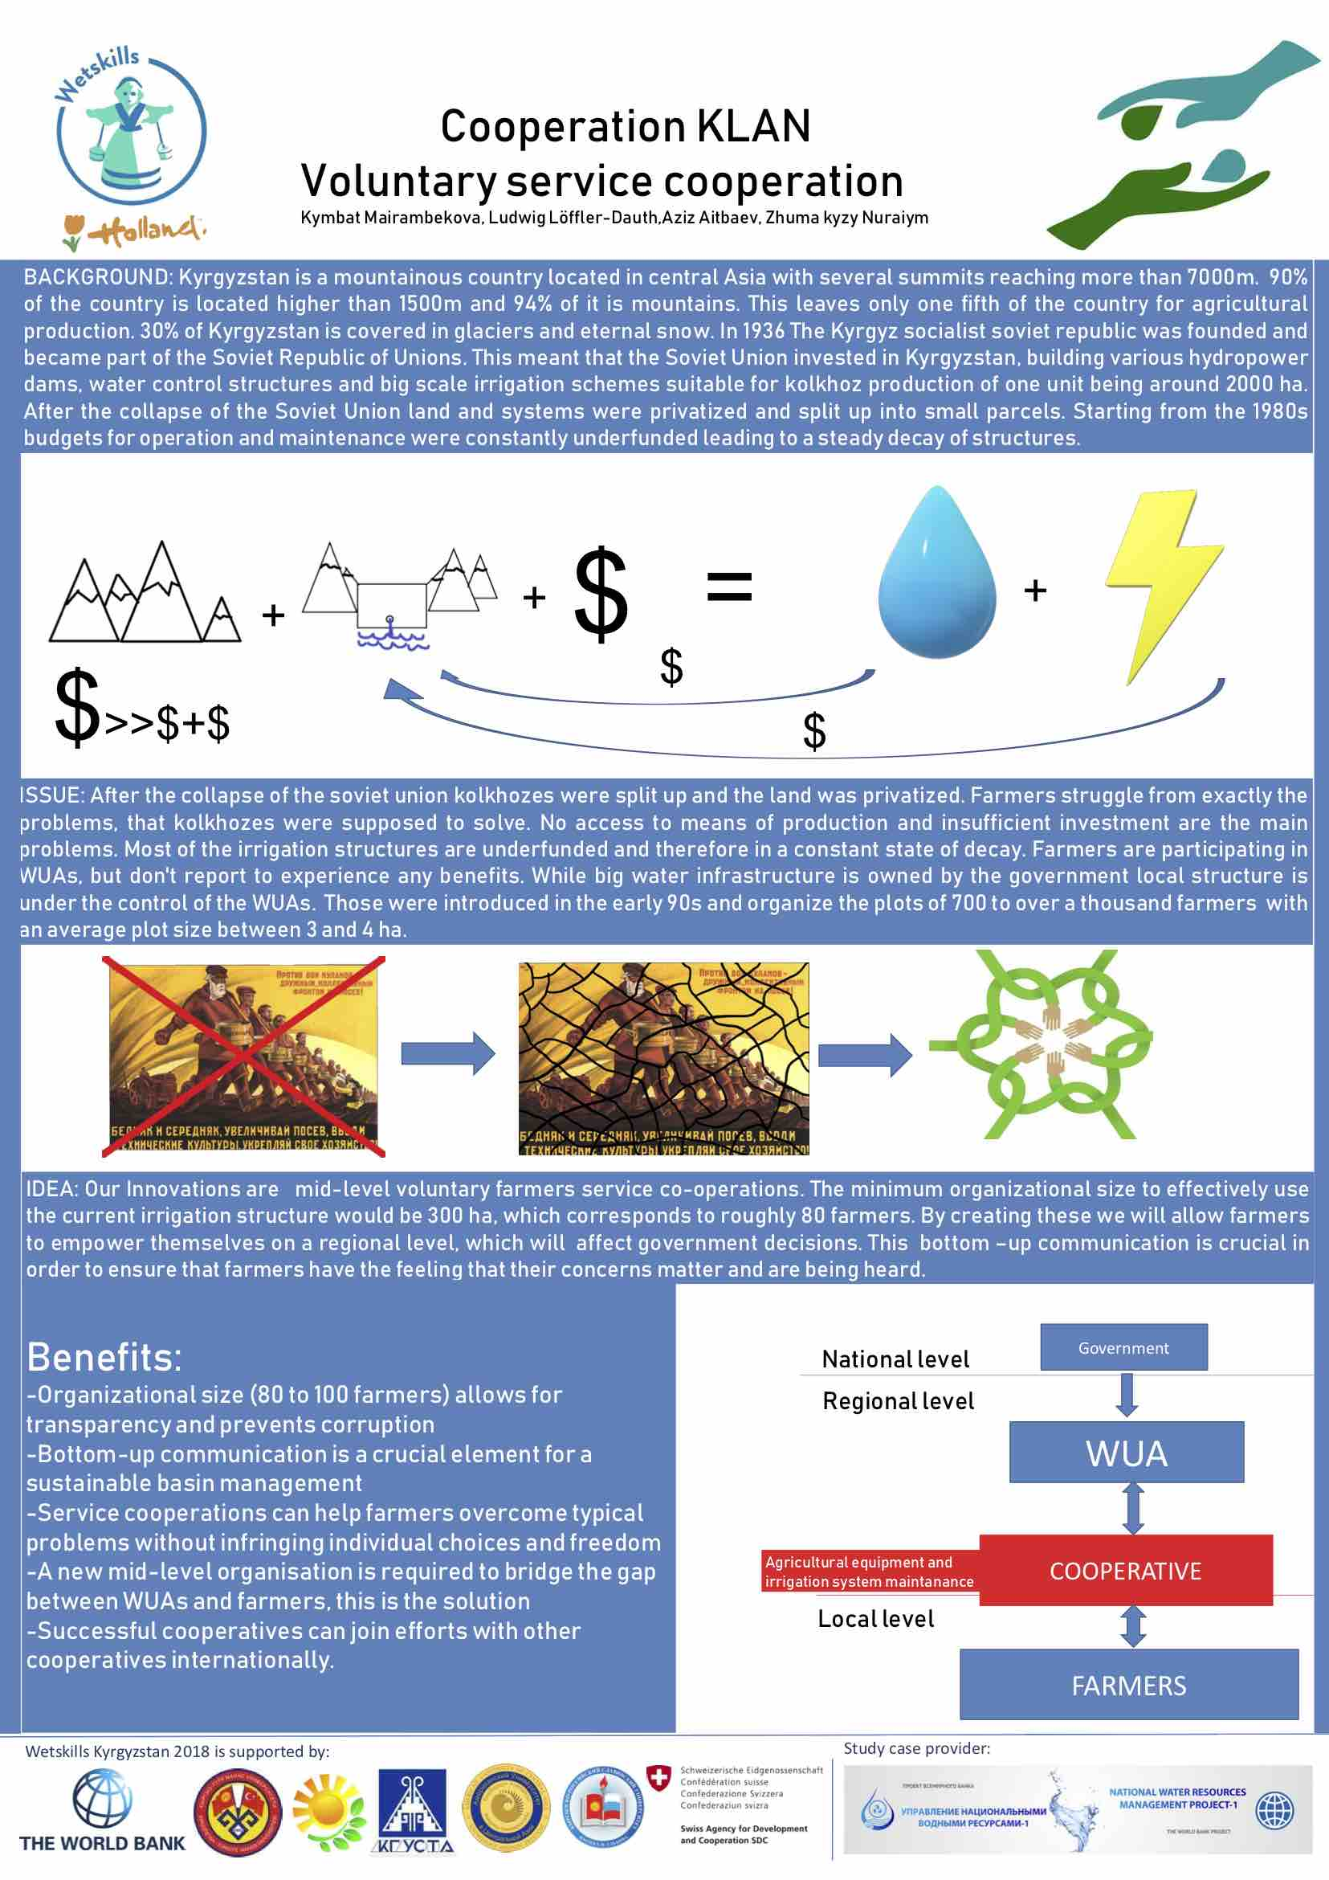

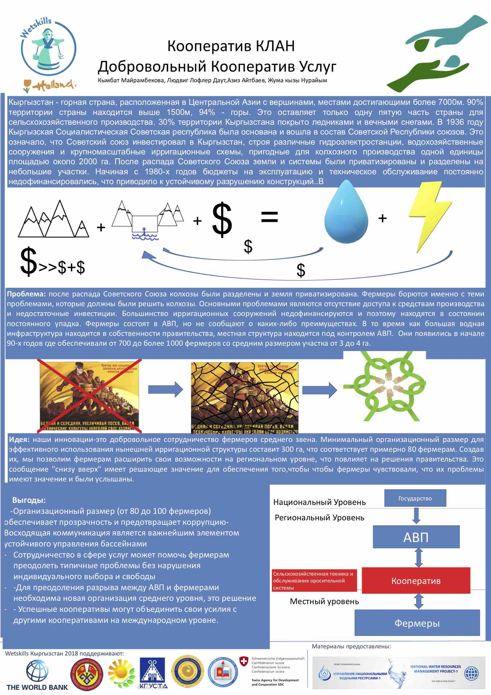

Paper outline (memo) for Case study5

**Kymbat Mairambekova, Ludwig Löffler-Dauth, Aziz Aitbaev, Zhuma kyzy Nuraiym**

**This project was done for the Wold Bank in Kyrgyztan**

**Introduction of the case / Background: (Aprox. 150 words)**

Kyrgyzstan is a mountainous country located in central Asia with several summits reaching more than 7000m.  90% of the country is located higher than 1500m and 94% of it is mountains. This leaves only one fifth of the country for agricultural production. 30% of Kyrgyzstan is covered in glaciers and eternal snow.

In 1936 The Kyrgyz socialist soviet republic was founded and became part of the Soviet Republic of Unions. This meant that the Soviet Union invested in Kyrgyzstan, building various hydropower dams, water control structures and big scale irrigation schemes suitable for kolkhoz production of one unit being around 2000 ha. After the collapse of the Soviet Union land and systems were privatized and split up into small parcels. Starting from the 1980s budgets for operation and maintenance were constantly underfunded leading to a steady decay of structures.In the early 90s regional irrigation infrastructure was handed over to private Water User Associations. These were in charge of a whole irrigation scheme, managing between 700 and 1000 farmers, whith average plot sizes between 3 and 4 hectar. The smallest plots only measuring 1 ha.

**Problem Statement: (Aprox. 100 words)**

One of the experts stated that it was a big mistake that after the collapse of Soviet Union in 1991 the land were distributed between people in small pieces. So, this actions sequent many tensions between individual farmers, which mostly concede to the to the large collective farms, which included the team of experts in agricultural field. To define a real problem statement seems to be not an easy task. According to the data that we collect combining with expert opinions we defined several problems connected to our topic. So, we decided to list all of them and prioritize what is more relevant and more effective applying to our case. Bad condition of irrigation systems, decentralized agriculture irrigation and not appropriate schemes of irrigation and water objects has created lots of tensions and misunderstanding between farmers, governmental officials and stakeholders such as Water User Assossiations (WUA).

**Objective of the study: (in one sentence)**

Is it possible to voluntarily create cooperatives that are able to maintain the existing irrigation infrastructure and what could support them from a technical perspective?

**Scope of the study / terminology: (Aprox. 100 words)**

Since technical solutions are complicated and costly we try to focus on a river basin management approach. Dr. Elena Drugaleva told us, that organizational units would have to be at least 300ha to use the existing structures properly. We will try to come up with an idea on how to motivate farmers to try to implement a uniform crop cycle in order to use the system like it was scheduled. We will also try to think of technical solutions, as a supporting measure.

**Method and data:**

We talked to experts, representatives of WUAs and conducted and independent field trip.

We also did an extensive literature research and found studies about how informal and formal cooperation is already practiced and what how people perceive the benefits. A trip to the field and an interview with a farmer helped us understand underlying problems.

**Results / solution:**

Farmer and expert interviews showed that the main problem in the region is not so much current water shortages, and more a lack of agricultural means of production and the ability to invest in such. These are classical problems in a developing agricultural society. The communist answer were production cooperations, which worked good as long as there was an authoritarian state willing to enforce sanctions for people that did not participate. In post-soviet Kyrgyzstan we find can still find a small number of service cooperations, and people that join them indicate a better wellbeing than the ones that don’t (Lerman & Sedik, 2016). In the developed west (EU and USA) Service cooperations are widespread, with roughly 30% of farmers participating in them ( (Mather, DeVille, Gessner, & Adams, 2004). The question is now how can these cooperations work in Kyrgyzstan? An important step is to create an awareness of the idea and feasibility of these cooperations. Especially the difference between service and production cooperations need to be highlighted. When asked why Kyrgyz farmers do not participate in cooperatives the primary reasons where that they there was no coop nearby (55%), that they fear to loose their independence (43%) , that they didn’t see possible benefits (24%) and that they had no information about coops (17%) (FAO/REU, 2012). These problems can easily be tackled by handing out information and organizing meetings that encourage the formation of cooperatives. A major issue for voluntary cooperations is freeriding. This can only be solved with making the cooperation a reliable and non profit way for farmers to lend money for agricultural inputs. By making the cooperative as attractive as possible more and more farmers will join. A major problem in Kyrgyz administration is the lack of transparency, which is ensured by the size of cooperations. If people know each other personally freeriding and embezzlement have serious social consequences in everyday live. A crucial point is of course that there is a legal framework that allows farmers to start these cooperatives and give them the possibility to put pressure on regional WUAs and governments.

**Concluding remarks / recommendations:**

Cooperations are a great way to avoid overexploitation of common resources and freeriding. The implementation should be organized by private stakeholders to encourage farmers to empower themselves. The idea might be old for some countries but is radical and new in modern Kyrgyzstan.

# References

FAO/REU. (2012). *Survey of registered cooperatives and peasant farms across Kyrgyzstan.* Bishkek: El-Pikir.

Lerman, Z., & Sedik, D. (2016). *Cooperatives in Kyrgyzstan: Findings from a Survey of Cooperatives and Users.* The architecute of food safety control in EU and Eurasian Economic Union.

Mather, J., DeVille, K., Gessner, A., & Adams, C. (2004). *Farm marketing, supply and service cooperative historical statistics.* Washington DC: USDA.