Wetskills goes to Bangladesh!
For the first time ever, Wetskills Water Challenge is going to Bangladesh! Through cooperation with the Bangladesh University of Engineering and Technology and the Urbanizing Deltas of the world programme – CORE project, Wetskills will be in Dhaka and Sirajganj at the beginning of July 2019. The Community Resilience through rapid prototyping of flood proofing technologies in urban areas (CORE) project partners BUET, IHE Delft and HKV Consultants and some SMEs will collaborate with Wetskills to bring fresh perspectives to their pilot project in Sirajganj. Join us for a flood resilience challenge during monsoon season in Bangladesh!
The Wetskills Foundation invites Bachelor, Master, PhD students and recent graduates to apply for the Wetskills Water Challenge Bangladesh. This edition of Wetskills will take the participants not only to the capital, Dhaka, but also to the nearby city of Sirajganj where the CORE pilot project is developed. This event will be organized in close cooperation with BUET and the Dutch partners in the CORE poject. The finals will be organized during a dedicated event in Dhaka on the 12th of July.
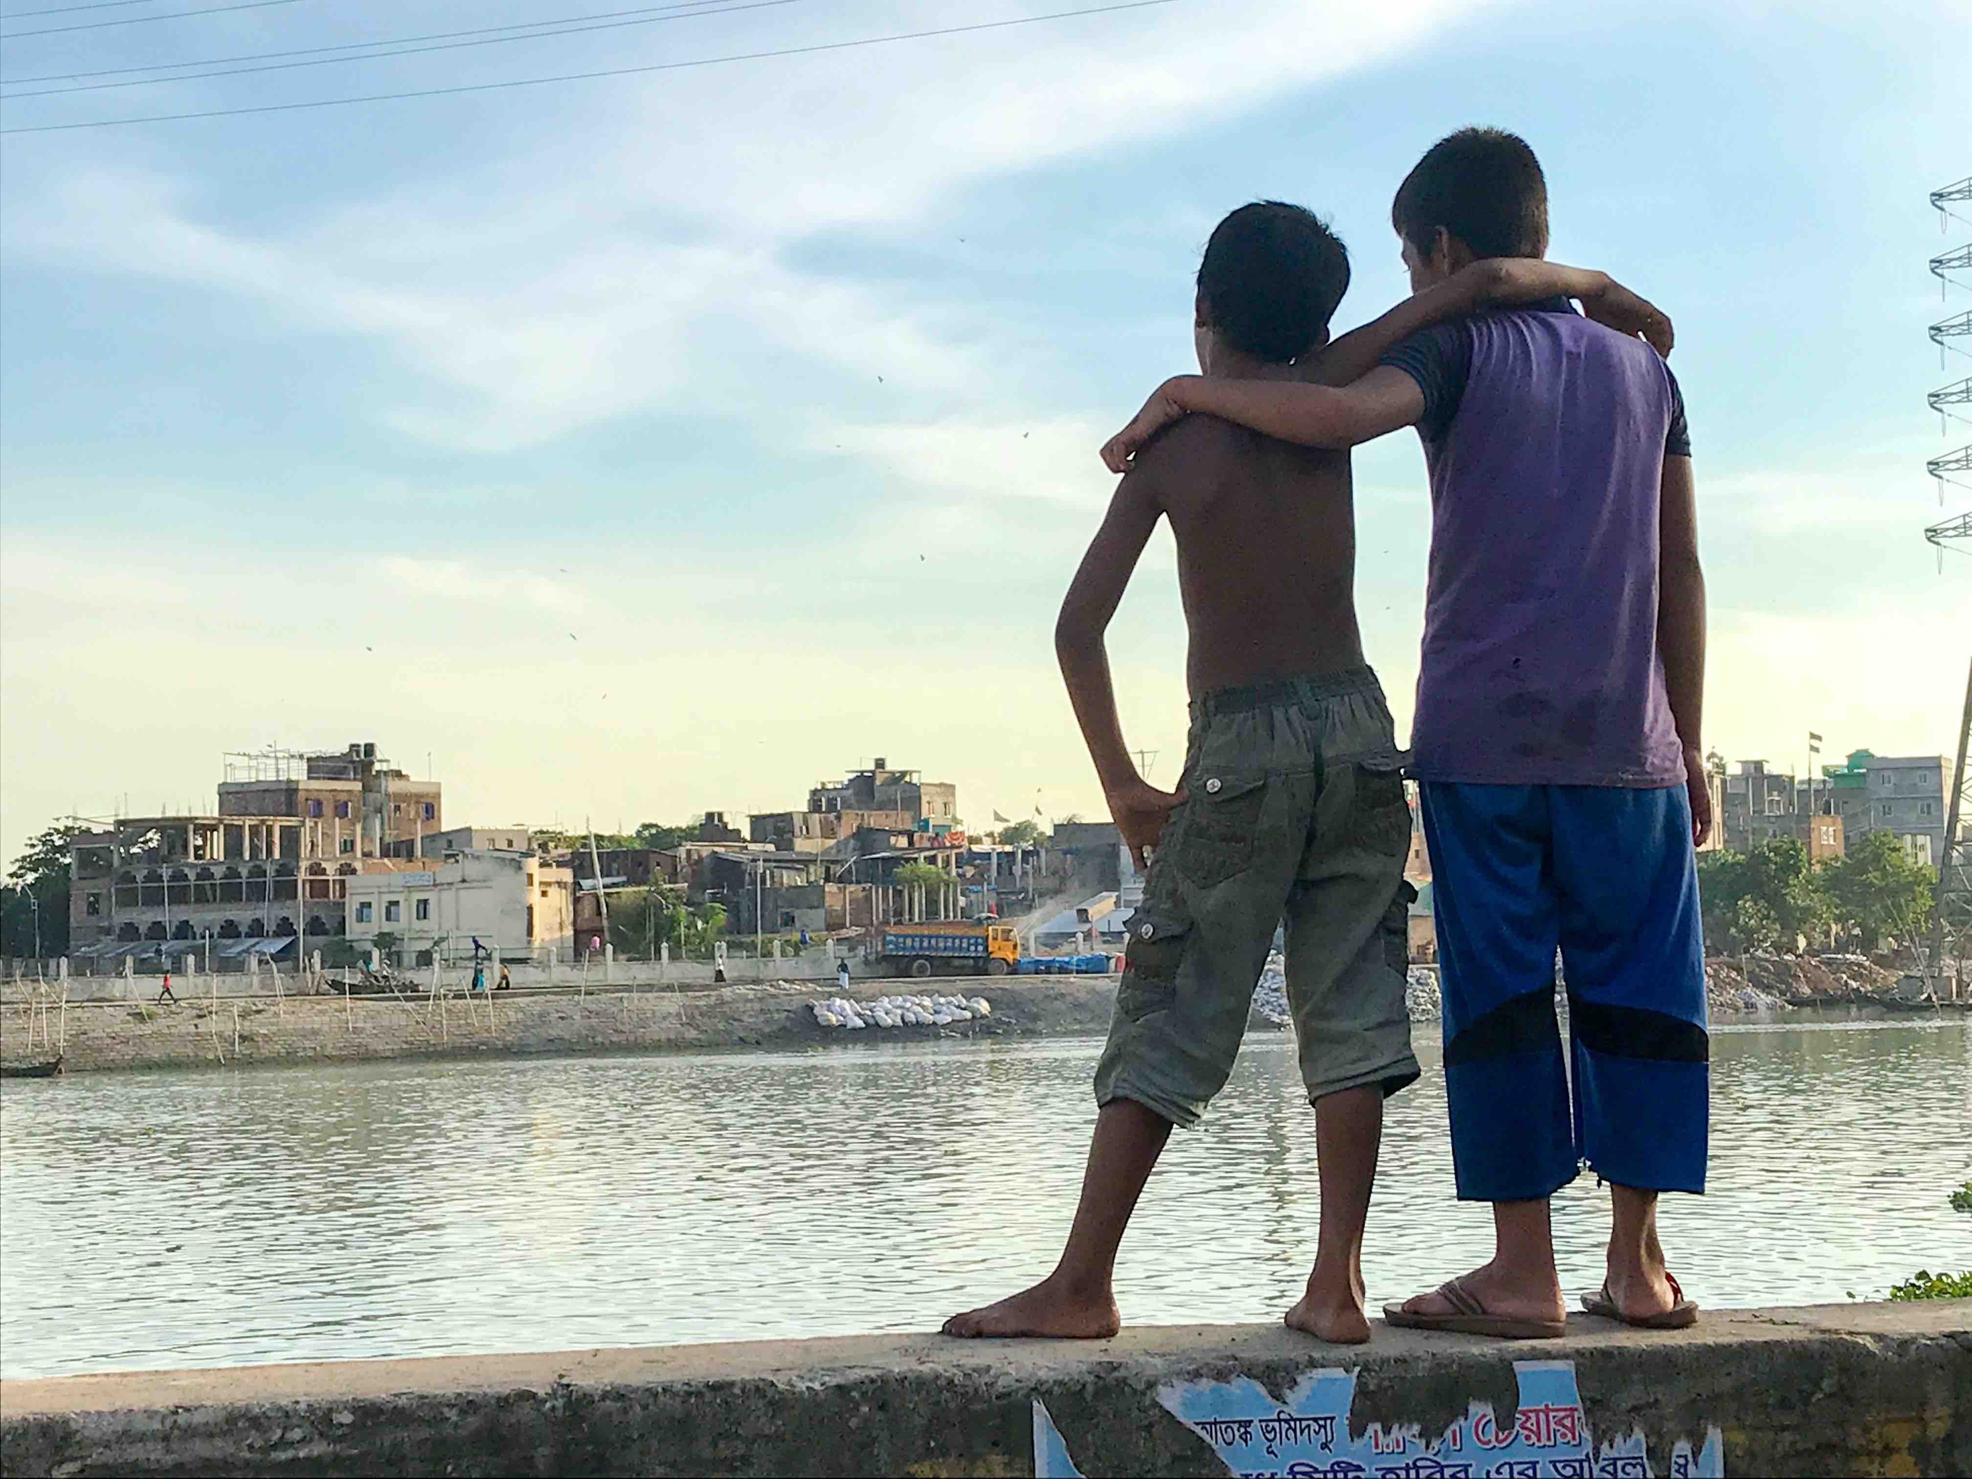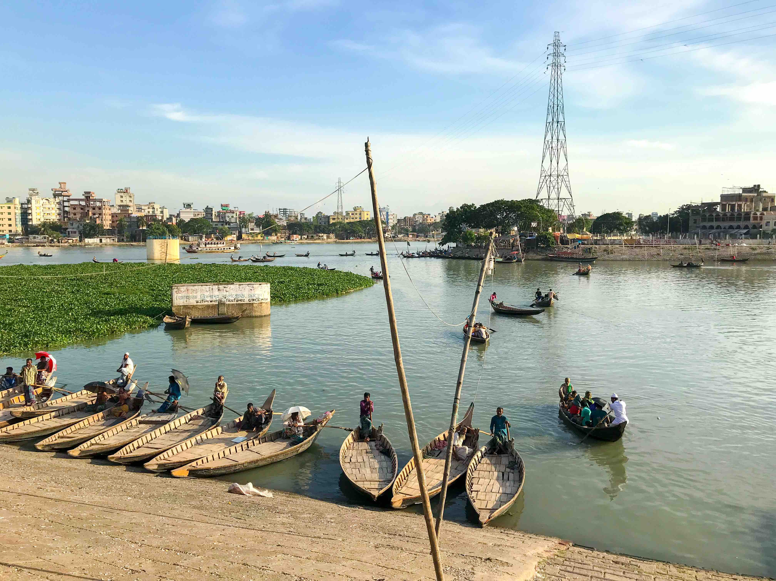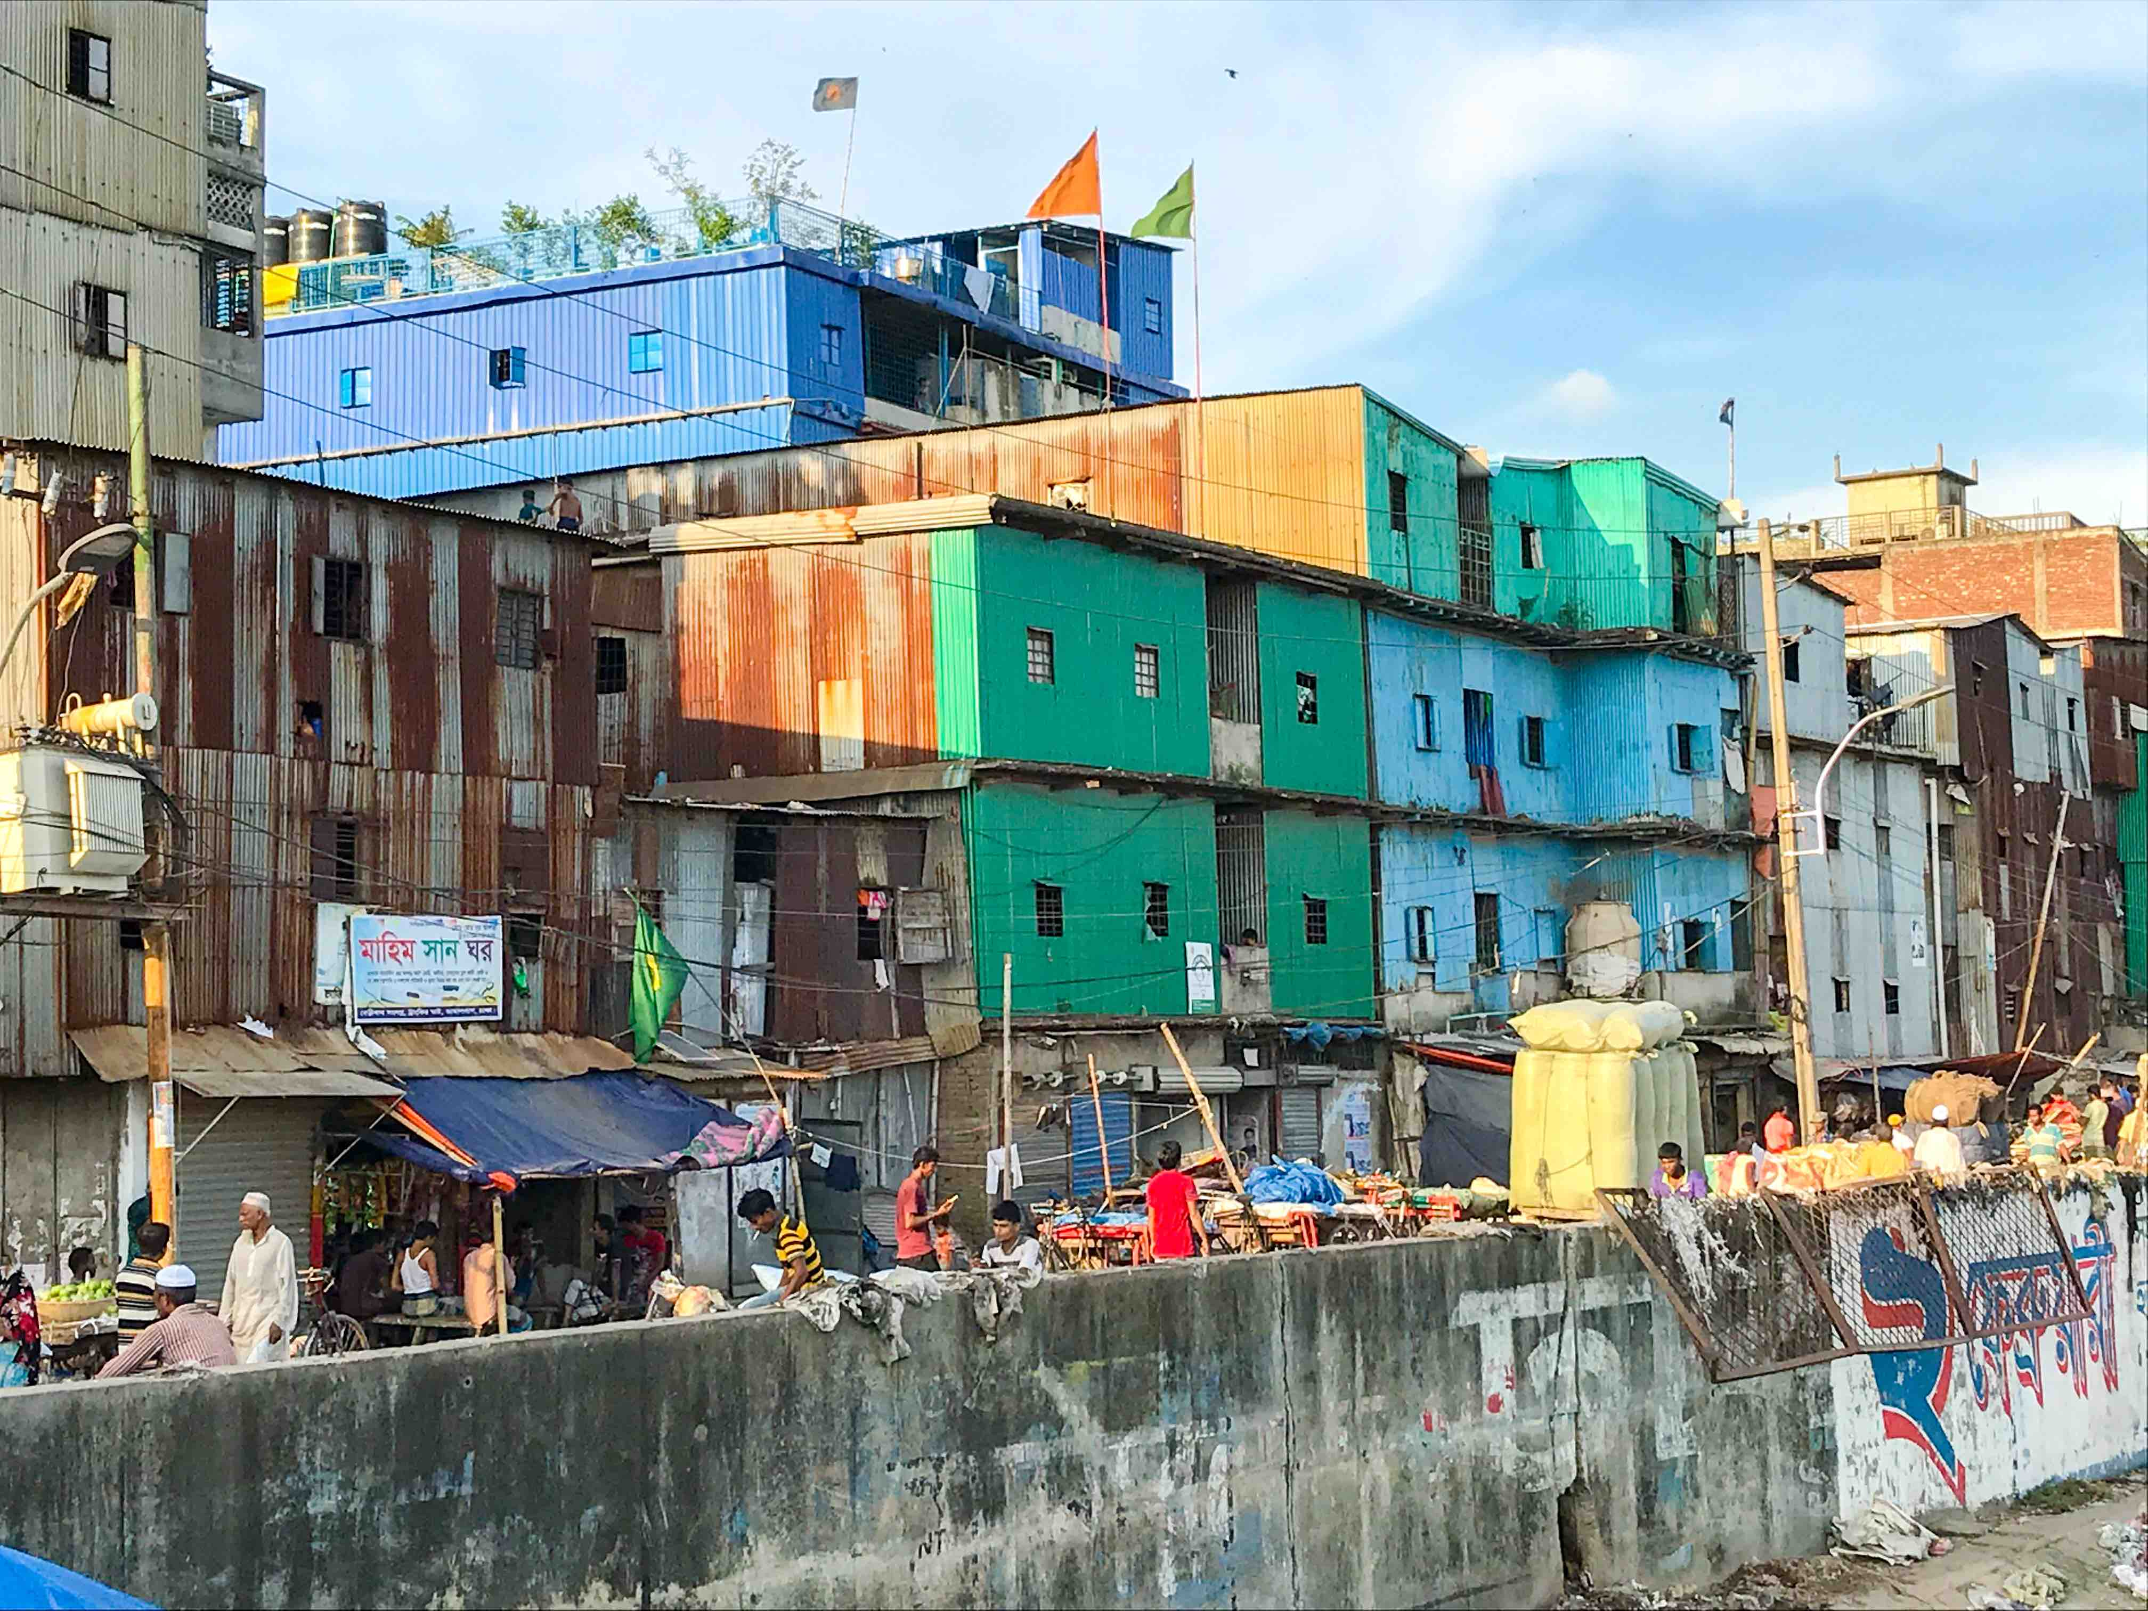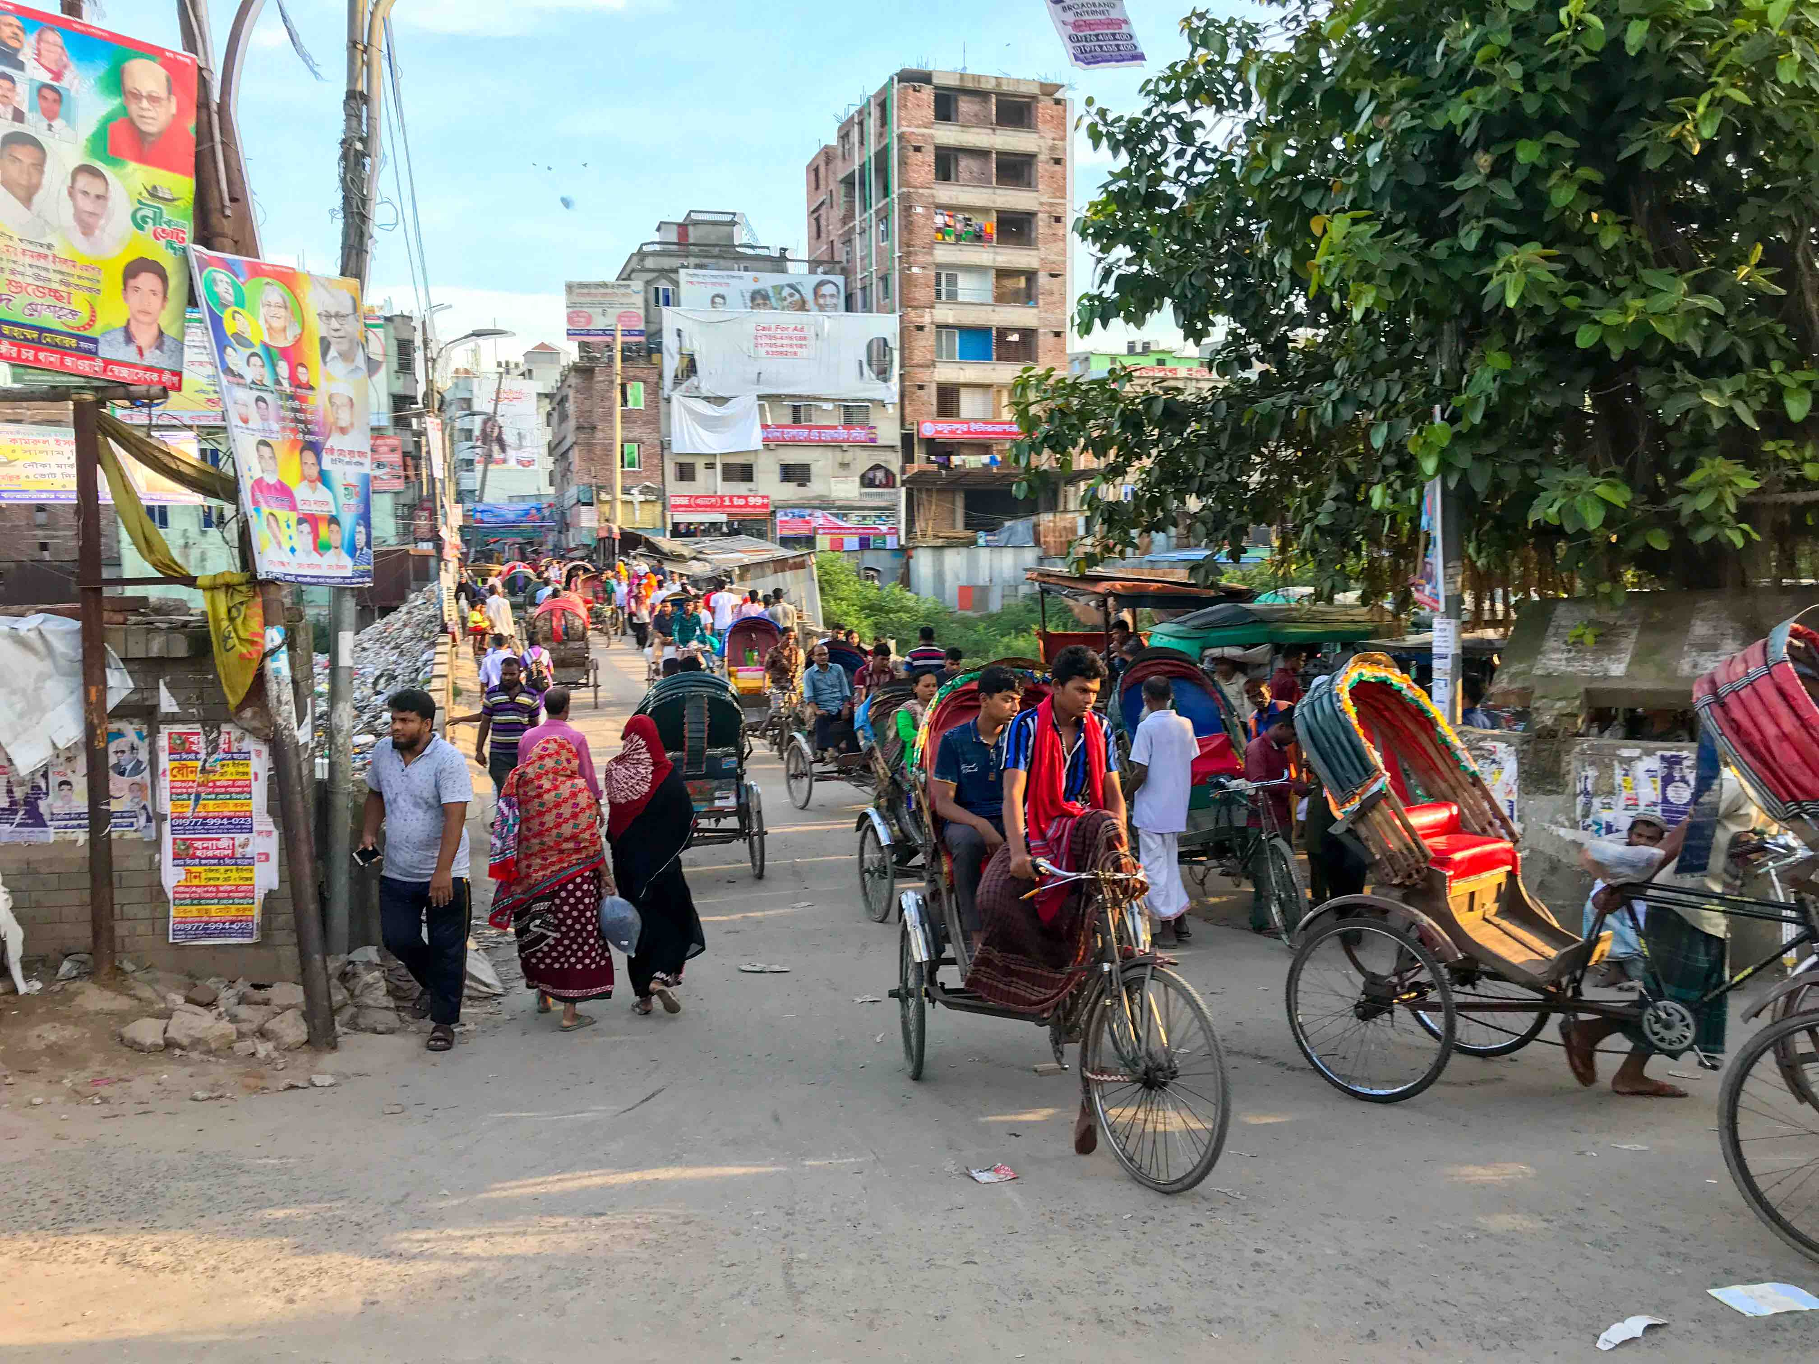
Wetskills Water Challenge Bangladesh: 30 June -12 July 2019 (Dhaka and Sirajganj)
During the two-week program, participants will work in mixed and multidisciplinary teams of about five students to develop innovative, 'out of the box' solutions for case studies brought in by organizations and companies from the water sector. Arriving in Dhaka, the participants will first get to know each other through some teambuilding activities and visit the capital. The program will start with a field visit to Sirajganj from the 30th of June until the 2nd of July, visiting the CORE pilot project site and other water-related and cultural locations around the city. Upon return to Dhaka, the challenge will start officialy with the BrainHurricane, where the cases will be briefly introduced by the case owners at the Bangladesh University of Engineering and Technology; the host of this Wetskills event. In a speed date session with experts the teams get information regarding their case. After this BrainHurricane the teams get to work on their cases for several days at the university. The supervisors will guide you during the two-week program and facilitate your team to find its own innovative concept. For the final stretch of the program, including the pitches and awarding ceremony, BUET will organize a dedicated event with international participation from organizations in and around Dhaka.
Since 2010, more than 650 students and young water professionals from about 150 international universities and organizations have participated in one of the 33 Wetskills Water Challenges organized in Asia (China, South Korea, Taiwan, Kyrgyzstan, Indonesia and India), North Africa & Middle East (Iran, Oman, Morocco, Israel and Egypt), Sub-Saharan Africa (South Africa & Mozambique), Europe (Romania, United Kingdom & the Netherlands and North America (United States & Canada).

Deadline for application and selection: 15 April 2019.
Afterwards every two weeks a selection of the new applications till the program is full. (First Come, First Served)

Who can apply?
Any Young Water Professionals (up to 5 years of working experience) and final year Bachelor, Master or PhD student and recent graduates with passion for water and intercultural teamwork.

How can I apply?
Prepare a motivation letter & resume, go to www.wetskills.com, fill-in & submit the online application form on the website.

Selection criteria
The Wetskills organization will make the selection among applications received. The selection is based on quality of motivation letter & resume.

What are the costs?

Participation costs for international participants are 150 euros or equivalent in Bangladeshi Taka (excl. 21% VAT). The fee includes accommodation, programme costs, supervision, some social activities, field trips, working locations, presentations by experts and the awarding event. It does not include transport, some meals, other daily costs. Participants are responsible for their own travel expenses (like plane tickets and some local travel), meals during working days and other personal costs.

Local participants, who do not need accommodation, can participate free of charge, incl. the above arrangements!

Note: During past editions participants often successfully arranged financial compensation for their Wetskills participation from their university or employer. We therefore strongly encourage applicants to inquire about funding opportunities to compensate the costs (university mobility funds, travel allowance etc.).
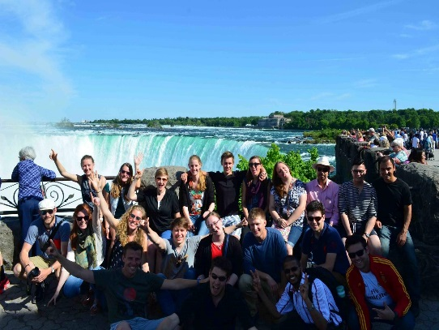
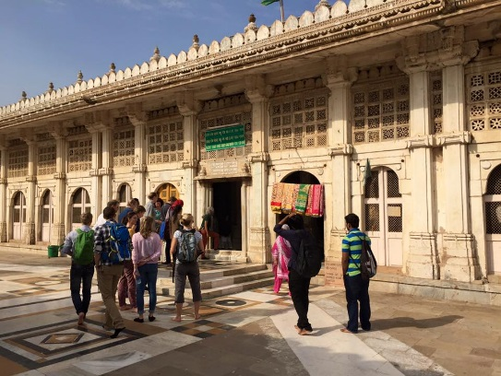
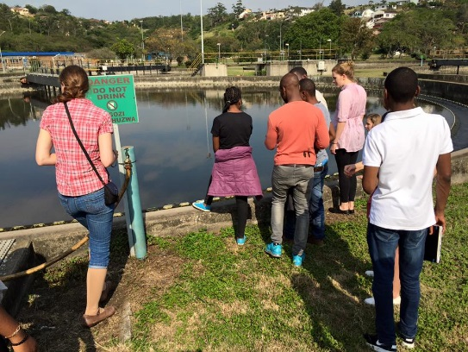
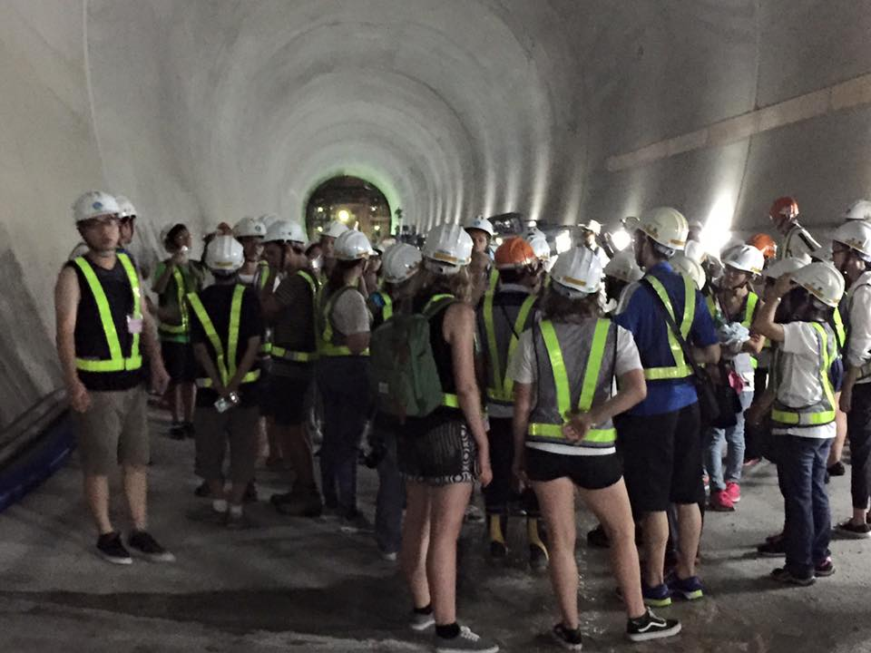
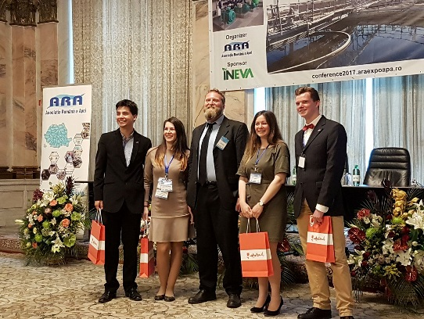

Wetskills Canada 2014

Wetskills Taiwan 2016

Wetskills Romania 2017

Wetskills India 2015

Wetskills South-Africa 2016

What do I get?
A unique learning experience where you will tackle real-world water challenges!
- You will increase your skills in: international cooperation; problem solving, cross-cultural and interdisciplinary teamwork, networking and presenting (pitch & poster);
- You will get the opportunity to connect with other international water students/young professionals;
- You will visit Dhaka, Capital of Bangladesh & the rural area of Sirajganj; water-related sites & water professionals;
- You will learn and experience more about the Bangladeshi and Dutch water sectors, the main stakeholders and organizations, contemporary issues and current business opportunities;
- You will receive a certificate of participation upon completion of the program.

More information

For more information about participating in this event, contact Ioana Dobrescu (ioana.dobrescu@wetskills.com) or Tim van den Staaij (tim.van.der.staaij@wetskills.com). For other information contact Johan Oost (johan.oost@wetskills.com).

